© 2003 Fred Ringwald & Steve White: California State University Fresno
ringwald@csufresno.edu

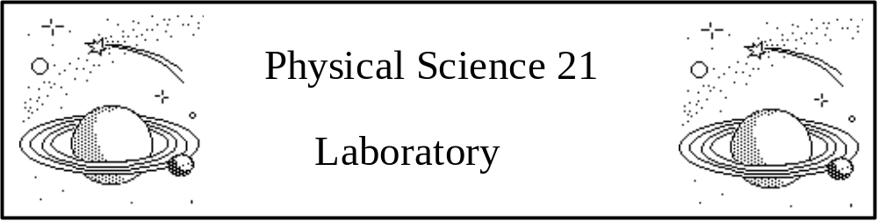
The Revolutions of the Moons of Jupiter

PURPOSE: To measure the orbits of Jupiter's moons, and to use Kepler's Third Law to find the mass of Jupiter.

Why is this important? This lab gives a taste of just what it is that observational astronomers (and most experimental scientists of all kinds) do in their day-to-day work. They measure from their observations (or experiments), look at the numbers carefully, and use patterns in these numbers to find new knowledge about the Universe.

REQUIREMENTS:
This lab is to be done in groups of two. One student is to use the computer and mouse, and the other is to record the data. You should switch off, though, so everyone gets a chance to use the computer. This lab is a computer simulation, which is based on the real orbits for each moon: if you were to set the simulation for today's date and time, you could verify the positions of Jupiter’s moons by observing them with our telescopes.

INTRODUCTION AND HISTORICAL BACKGROUND:
In 1609, Galileo Galilei heard of an invention by Hans Lippershey, a Dutch spectacle maker. By using two lenses, Lippershey found that distant objects could be made to look nearer. This instrument was called a spyglass. Without even having seen an assembled spyglass, Galileo was able to construct his own telescope, and soon became famous as the builder of the world's best telescopes.

Galileo immediately began to observe objects in the sky. He was a careful observer, and in 1610 published a small book, "The Starry Messenger." His discoveries caused great excitement. Suddenly, whole new worlds were opened! Galileo found spots on the Sun, and craters on the Moon. He found that Venus went through a series of phases, much as the Moon has phases. He was able to tell that the Milky Way was composed of "innumerable stars". He could see there was something strange about the shape of Saturn, but his small telescopes could not quite resolve its rings.

Galileo also discovered the four largest moons of Jupiter, and recorded their positions night after night. Jupiter and its moons form a "miniature Solar System," with the moons moving around, or orbiting, Jupiter. These four moons are now known as the Galilean satellites. Their names are Io, Europa, Ganymede, and Callisto, in order of distance from Jupiter. One can remember the moons in order with the memory aid "I Eat Green Carrots."

In 1543, Nicolaus Copernicus had published a theory that all the planets, including the Earth, move in circular orbits around the Sun, and that only the Earth’s Moon orbited the Earth. The Galilean satellites provided the first clear evidence that the Copernican theory was physically possible. Prior to Galileo’s discovery, an objection to the Copernican theory was that a moving Earth would leave its Moon behind. The motion of the satellites around Jupiter proved that a moving planet would not lose its moons.
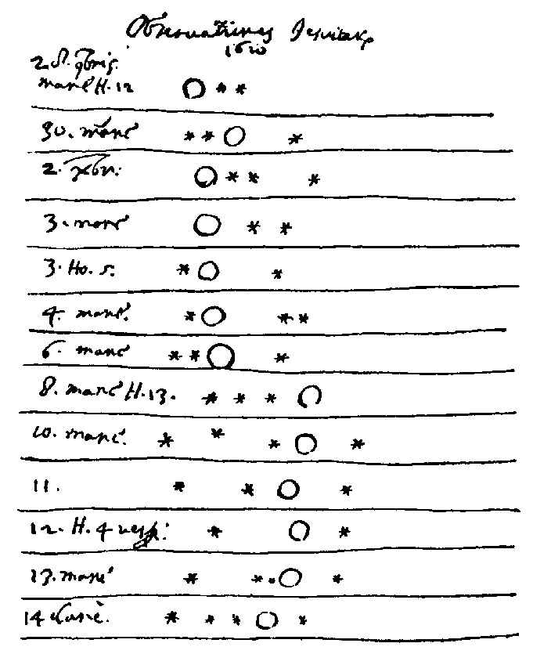

Figure 1. Galileo’s drawings of Jupiter and its four largest moons, during 1620.

Many people were upset by the idea that the Earth was not the center of the Universe, and Galileo was ordered in 1616 neither to "hold nor defend" the Copernican theory. Nevertheless, in 1632 he published his Dialogue on the Two Great World Systems, which was a thinly disguised defense of the Copernican system. This led to his forced retraction, under the threat of torture, and confinement to his home for the rest of his life.

KEPLER'S THIRD LAW:
Over 20 years up to 1601, the Danish astronomer Tycho Brahe carefully used a sextant and compass to observe the locations of the planets and stars. These observations were used by his assistant, Johannes Kepler, to deduce three mathematical laws governing the orbit of one object around another. Kepler's Third Law (1619), for a moon with a circular orbit around a much more massive parent body (here, the planet Jupiter), is:
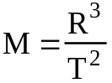

R is the radius of the orbit, measured in Astronomical Units, or A.U. One A.U. is the average distance from the Earth to the Sun.

T is the period of the orbit, measured in years. The period is the time required for a moon to complete one orbit around its parent body (here, the planet Jupiter).

Kepler’s finding was empirical: he could show from the observations that this law works, but he didn’t know why it worked. In 1687, Isaac Newton showed why: a moon’s orbit depends on how strong its parent body’s gravity is. Gravity depends on mass, so that:

M is the mass of the parent body, in solar masses. (The Sun has 1 solar mass.)

We will use computers to simulate observing one of the four Galilean moons of Jupiter. The moons appear to be lined up because we are looking edge-on to the Jupiter system. As time goes by, the moons move around Jupiter, each one following its own circular orbit. From Earth, we will see the moons traveling in a back-and-forth motion.

R
Jupiter
orbit
moon
Jupiter and one of its moons, as seen from Earth.
Again, Jupiter and one of its moons, seen from a point above Jupiter.
To Earth
x

Figure 2.

From this figure, we see that x is the moon’s apparent distance from Jupiter, as we see it from Earth. Therefore, a plot of x versus time should give a curve that repeats: such a curve is called a sinusoid, or a sine wave. One repetition of this curve is called a cycle. By taking enough measurements of the position of a moon, one can fit this curve to the data and determine the radius of the orbit, also called the amplitude of the cycle. One can also find the period of the orbit, which is the time it takes to repeat. Once one knows the radius and period of the orbit of that moon, and converts them into appropriate units, one can find the mass of Jupiter by using Kepler's Third Law. We will determine Jupiter's mass using the data from one of the four moons. It is really quite amazing that we can use careful observation and a law of nature to determine the mass of Jupiter!

Using the computer controlled telescope to take data

1. You must first select Log In from the menu before taking data. You don’t need to enter your names: just hit “Return” to get by this.

2. Choose one of the four moons. Important: Before taking any data, set the corresponding observation interval:

Io 2 hrs
Europa 4 hrs
Ganymede 6 hrs
Callisto 8 hrs.

IMPORTANT: Ask your lab instructor to check this, before going any further.

(Note to lab instructors: make sure the students get this right, since the data will be useless if they use the default value of 24 hours, since they are too sparsely sampled for all the moons except Callisto.)

3. You can display the screen at four scales of magnification by clicking on the 100X, 200X, 300X and 400X buttons at the bottom of the screen. In order to improve the accuracy of your measurement of a moon, you should use the largest possible magnification that leaves the moon on the screen.

4. In order to measure the apparent distance of a moon from Jupiter, move the pointer until the tip of the arrow is centered on the moon and click the mouse. Information about the moon will appear at the lower right corner of the screen. This includes the name of the selected moon, the x location on the screen, and the apparent distance (in units of Jupiter diameters) of the moon from Jupiter. Also included is an E or W, to signify whether the moon is east or west of Jupiter. If the moon's name does not appear, center the arrow more exactly on the moon: it should show up. Record the moon's position in the data table. Use + for west and - for east. For example, if Europa were selected and it had an x = 2.75W, you would enter +2.75 in column 3 (position) in your Data Sheets.

5. When you have recorded the Universal Time and the position (or apparent distance from Jupiter) for your moon in the Data Sheets, you may make the next observation by clicking on the Next button.

6. You should take enough data points to fill up all the rows in both tables in the Data Sheets, below. When you have finished taking readings, you may quit the program by selecting Finished from the menu.

7. In order to make the simulation more realistic, every now and then, you get a blank screen and a message about "cloudy weather." Leave this entry blank: don’t enter zero, because it isn’t zero, it should be blank, for no data. Go on to the next reading.

Plotting the Data

Plot the data for the moon you chose on the graph paper provided. Each measurement of a moon's apparent separation from Jupiter will give you one dot on the graph for that moon. Then draw a smooth curve through the points.

By plotting position versus time, you will use the data to draw a graph similar this:
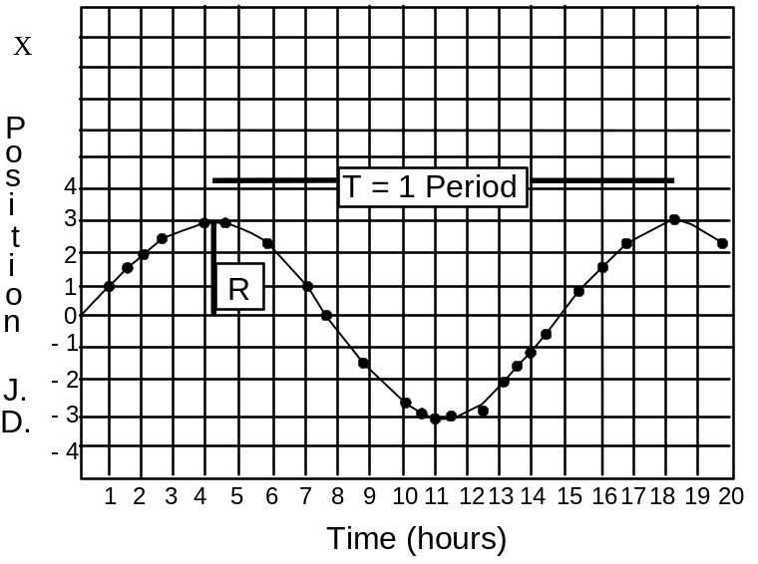
Each dot in the figure is one observation of the moon you chose. Note the irregular spacing of dots, due to poor weather and other problems on some nights. The curve drawn through the points is the smooth curve that would be observed if you decreased the observation interval enough. The shape of the curve is called a sinusoid, or sine wave.

Using the data from the moon you choose, you can find the radius and period of the orbit. The period is the time it takes to go all the way around the orbit. Thus the time between two peaks is the period, T. The radius of the orbit, R, is the greatest apparent distance your moon is from Jupiter. This is also the greatest distance (in Jupiter diameters, or J.D.) the peak is from zero. You can read both R and T directly from your plot, as you can in the one above.

DATA SHEET Moon:_____________________

Example:
(1) | (2) | (3)
Day # | Time (hours) | Position  (+ is West,  - is East)
2 | 2 | +1.72
(1) | (2) | (3)
Day # | Time (hours) | Position  (+ is West,  - is East)
(2) | (3) | (4)
Day # | Time (hours) | Position  (+ is West,  - is East)
Name: _____________________________ Your lab day: Mon Tues Wed (Circle one)
Lab Instructor: _______________________ Time: 5:30 p.m. 7:30 p.m. (Circle one)
Plot the data you measured, and read off the period, T and the orbital radius, R from your graph for whichever one of the four moons you chose. These values will have units of hours for the period T, and Jupiter Diameters (J.D.) for R. Enter your results here:

T (period) = _________ hours R (orbital radius) = ________ J.D.

Be sure to attach your plot to this page, and write your name on your plot (in case it gets separated from this page).

In order to use Kepler's Third Law, you need to convert the period into years, using:
1 day = 24 hours and 1 year = 365.25 days.

The orbital radius must be converted to A.U., using 1050 J.D. = 1 A.U. Enter your converted values here:

T (period) = _________ years R (orbital radius) = ________ A.U.

You now have all the information you need to find the mass of Jupiter with Kepler's Third Law, in which:
where: M is the mass of Jupiter in solar masses. (The Sun = 1 solar mass.)
R is the radius of the orbit in A.U.
T is the period in years.

Calculate the mass of Jupiter, using the results from the motion of your moon.

Moon: _________________ MassJupiter = __________________ solar masses

QUESTION: The Earth's Moon has an orbital period of 27.3 days and an elliptical orbit with a semi-major axis of 2.56 x 10-3 A.U. What is the mass of the Earth? In what units? Show your work.

