Name:
Lab Partner:

The Flow of Energy Out of the Sun
Student Manual

A Manual to Accompany Software for
the Introductory Astronomy Lab Exercise
Edited by Lucy Kulbago, John Carroll Univeristy
11/24/2008

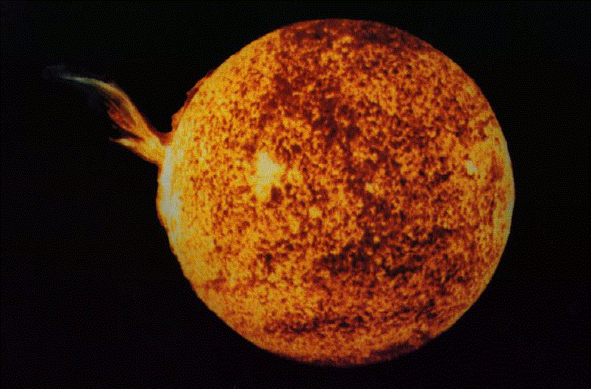


Department of Physics
Gettysburg College
Gettysburg, PA

Telephone: (717) 337-6028
Email: clea@gettysburg.edu

Contents

Goals 3

Introduction 4
The Solar Atmosphere 4
The Solar Interior 4

Getting Started 4
Equipment 4
Starting the Program 5

Exercises 5
Exercise 1: Interaction 5
Exercise 2: Line Formation 5
Exercise 3: Continuum 6
Exercise 4: Experiment 7
Exercise 5: Flow 9
Exercise 6: Photon Diffusion 11
Exercise 7: Essay Question 13
Exercise 8: Essay Question 14

Goals

Overall

Using the computer simulation, you will explore the interaction of photons with gas atoms

Specific

If you learn to

Recognize the effects of absorption and re-emission by individual atoms

Recognize the effect a photon’s energy has on the rate of absorption by a particular gas

Observe and describe the effects of diffusion and its dependence on the number of layers of gas in the star.

You should be able to

Understand how the absorption and emission lines we see in stellar spectra are produced

Understand why it takes a photon a long time to travel from the center to the surface of the Sun.

Introduction

The CLEA program, The Flow of Energy Out of the Sun, is designed to teach you how photons travel from the core of the Sun to the surface and how they interact with matter on their way into space. They interact in two general regions with two different effects:

- A few photons are absorbed and re-emitted by atoms in the solar atmosphere, producing absorption lines or dark lines in the Sun’s spectrum. The solar atmosphere is a thin layer of gas that makes up the outermost skin of the Sun. It is largely transparent, so it has little effect on most of the photons.
- Before they reach the atmosphere, photons generated in the core of the Sun travel through the main body of the sun, called its interior. They travel a zigzag path on their way out, as they are scattered back and forth by particles (mostly electrons). So many interactions occur, that it literally takes hundreds of thousands of years for a typical photon to travel from the center to the surface.

The CLEA program contains the following modules on these topics.

Solar Atmosphere

- A sub-microscopic simulation, called Interaction, allows you to study how an individual line or continuum photon interacts with atoms.
- The Line Formation simulation demonstrates how photons that have just the right amount of energy to kick an electron of a gas atom to a higher energy state are absorbed by the atom. These types of photons are called line radiation photons.
- The Continuum simulation shows how photons that do not have the precise energy required to be absorbed pass though a cloud of easily. These photons are called continuum photons.

- A final gas cloud simulation, Experiment, allows you to match a photon’s energy with various gas clouds. This process permits you to plot a line spectrum similar to what you might observe using a spectrograph attached to a real telescope.

Solar Interior

- In the Flow simulation, a two dimensional slice of the interior of a simulated star, is used to study how a photon diffuses outward from the core, and how the numbers of layers of atoms in the model affect the amount of time it takes for a photon to escape.

Getting Started

Equipment

A simple pocket calculator, pencil, graph paper (optional), PC computer using Windows, and the CLEA Computer Program The Flow of Energy Out of the Sun are needed to for this exercise.

Starting the Program

Open the Flow of Energy from the Sun exercise from the start menu. Select Log In... from the menu bar, and enter the requested information.

Exercises

Exercise 1: Interaction

Select Interaction from the Simulation menu to start. The display portrays many atoms in a gas. You see the electron cloud about the atom, its nucleus invisible and buried deep in the center. These simplistic pictures are for reference only. They are not drawn to scale. Atoms are seldom so round. You can change the scale by selecting Close-Up or Large-Scale from the View menu.
Select Line or Continuum from the Photon Type menu to choose the type of photons to be sent through the gassy region. Line photons have precisely the right amount of energy to be absorbed by the atoms. Absorbing a photon adds energy to the electrons in the atom, and they are kicked into higher orbits. After a brief moment, they fall to a lower energy state and release a photon in some random direction. These
photons are said to be undergoing
bound-bound transitions, since the
electrons remain attached to the same atom even when excited. Continuum photons are the wrong energy to interact easily with the atoms, and often pass through them without incident. Occasionally, a continuum photon will scatter off of an electron, but not often.
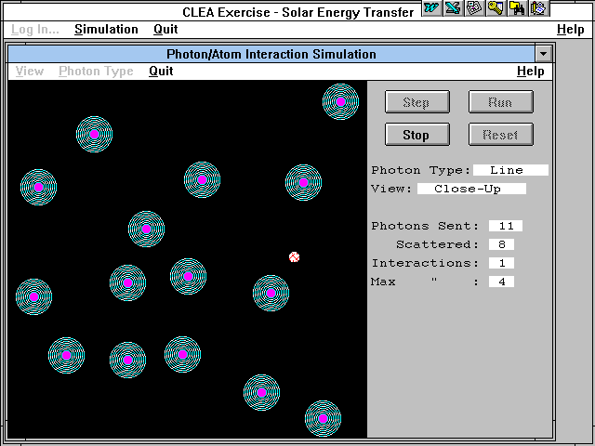

Figure 1
Photon/Atom Interaction Simulation

Choose line photons and click on the run button to watch how many photons are sent from the left side of the screen to pass through or interact with the atoms. Click on the stop button after 20 photons are sent.

How many line photons were scattered?____________________

(Alternatively, you can click on the step button to send a photon, one at a time, through the field. The photon enters the field from the left and is initially moving horizontally across the field.)

Repeat the demonstration with continuum photons.

How may continuum photons were scattered?__________________

Exercise 2: Line Formation

Select Line Formation from the Simulation menu to start. Each time you run the simulation, photons are sent through a container of gas. Photons enter the cloud from the left having come from a bright but off-screen object such as the Sun. Your detector is located at the right. Your detector views the Sun through the cloud. If a photon makes it through the cloud and is picked up by your detector, the “Detected” counter increases. The photon may interact with the cloud and get redirected and miss the detector. This situation is scored “Not detected.” If you want to start over, you can reset the numbers to zero by clicking Stop, then the Reset button.

Line photons have just the right amount of energy to excite an electron of an atom into a higher orbit. When the electron drops back down to its lower orbit, a photon is emitted. There is no method to determine which direction this photon will be emitted.

Select # of Photons (for “Run”) from the Parameters menu and enter 20. Click on the Run button to send them through the cloud.

How many of the 20 photons were detected? ____________________

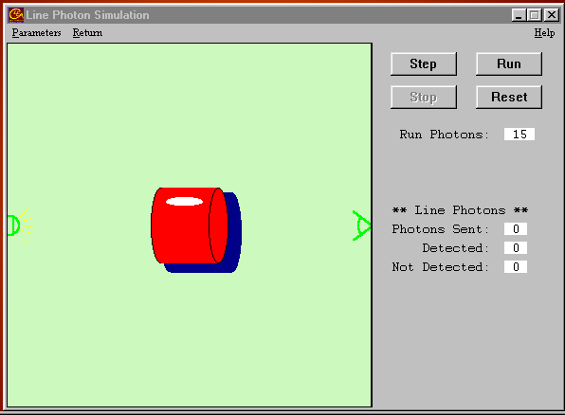
Line photons are responsible for the lines in a spectrum (hence the name). If you observe them against a bright background such as a star’s surface, they cause dark lines to appear, for as the simulation shows, most are scattered away. This is an absorption spectrum.
But if you observe line photons against an otherwise dark background, they cause bright lines in a spectrum. Such would be the case if you observed from a place which does not receive the direct photons, for instance if you put your detector at the bottom of the cloud instead of the right side. This is an emission spectrum.

Figure 2
Line Photon Simulation

Select Return from the menu bar to proceed to Exercise 3.

Exercise 3: Continuum

To begin Exercise 3, select Continuum from the Simulation menu. The configuration is the same, but this simulation uses continuum photons instead of line photons. The energy level of continuum photons is not well-matched to the atom of gas. Continuum photons provide either too much or too little energy to excite the electron. So most photons pass right through the electron orbits without interacting.

Send 20 photons through the cloud, as you did in Exercise 2.

How many of the 20 photons were detected? ____________________

Continuum photons give rise to the solid continuous rainbow of colors in a spectrum. They are the photons of various energies (and therefore colors) that can’t easily interact with the electrons of the gas, save occasional scattering. We observe a star’s light through its atmosphere, so pure continuous spectra are not normally observed. Nearly all spectra show tell-tale absorption lines characteristic of the cooler, less dense regions of the star’s upper atmosphere.

Select Return from the menu bar to proceed to Exercise 4.

Exercise 4: Experiment

Select Experiment from the Simulation menu to start. In the experiment mode, you are challenged to determine the energy level of a photon necessary to excite the atoms of various gases. You will plot the number of photons that pass easily through the gas at different wavelengths to see where the dark absorption lines appear. Exercises 2 and 3 demonstrated that the photon must have just the right amount of energy to accomplish this. You have a number of atoms available for study. They include thin gaseous clouds of Calcium (Ca), Hydrogen (H), Magnesium (Mg), Oxygen (O), and Sodium (Na).

Choose a gas by selecting Select Gas Atoms and the gas from the Parameters menu. Enter the name of the gas in Table 1 located on the following page. Select Change Photon Energy from the Parameters menu to set the photon energy to 1.5 eV. As you change the photon energy, the wavelength (the color) changes automatically since the two are related . You can reset the counters by using the Reset button. Be sure to reset the counters if you switch to a new a gas or a different energy level.

Select # of Photons (for “Run”) . . . from the Parameters menu and enter 20. Click on the Run button to send them through the gas cloud. Repeat at each energy level from 1.5 through 3.2 eV. Fill in the wavelength and number of detected photons for each energy level as you proceed. For example, if you send 20 photons through the gas at 2.3 eV energy level and 5 are detected, enter a 5 into the table. Be sure to reset the counters each time you change photon energy.

Complete Table 1 and then make a graph of your results, using the place provided on page 8. The range of the x-axis (horizontal) is 350 nm to 900 nm and is labeled Wavelength. The y-axis (vertical) is numbered 0 to 20 and labeled Photons Detected. Plot the data from Table 1 on your graph. Connect the points on the graph with straight lines. Although crude, you should be able to see a pronounced dip or several dips in the number of photons detected. The wavelength, and thus the energy of the dip, identify photon energies that easily energize the atom. Once energized, you know from Exercise 2 that most of the photons will be scattered away from an observer viewing the atom head on. Select Return from the menu bar to proceed to the next exercise.

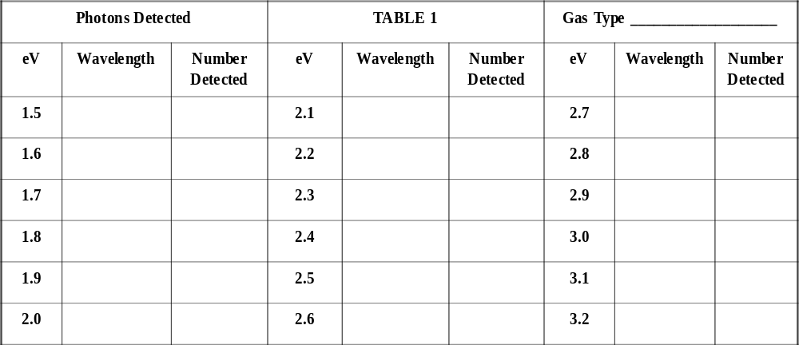

Table 1

Gas Absorption Spectrum

Gas Absorption Spectrum

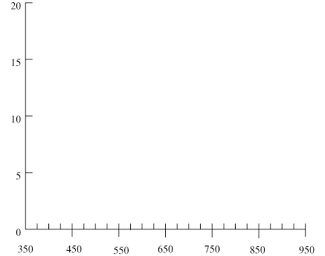
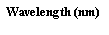

Exercise 5: Flow

To begin this exercise, select Flow…1 photon from the Simulation menu-bar.

A photon trying to escape from deep in the solar stellar interior follows a tortuous path. In a hot dense gas, like the interior of the Sun, three primary mechanisms affect the photons generally outward path. They are:
1. Electron Scattering
2. Bound-Free Absorption
3. Free-Free Absorption

Most atoms in the Sun, and other stars, are said to be ionized because the intense temperatures have stripped off most of their electrons.

Electron scattering occurs when a photon encounters an electron and causes it to vibrate or oscillate. The energy stolen from the photon in this process is re-radiated by the electron in some random new direction as a new photon.

In Bound-Free Absorption, a photon can be absorbed by an atom. The extra energy absorbed into the atom can ionize it, causing the atom to eject an electron. This free electron can recombine with another ionized atom some time later giving rise to the release of a new photon in some random direction.

Finally, in Free-Free Absorption, a photon can transfer its energy to an already free electron thus making the electron more energetic. The more energetic electron may give up this extra energy at any time in the form of a new photon, again to be radiated in some random direction.

All of these processes play a role in affecting a photon in the Sun though the interior electron scattering is most effective. The result of these processes is that every time a photon interacts with matter, it is redirected so that it travels in a new and complete random direction. The resulting zigzag path is called a random walk. This is graphically demonstrated in the Flow simulation.

Use the Flow simulator to explore the number of interactions required for a photon to exit the surface of the simulated star. Trails can be selected from the Parameters menu to trace out the photons crooked path. Trails are visually interesting, but remember that photons are not “eating” their way out of the Sun in any sense, they are just bouncing around. We generally do not turn on Trails.

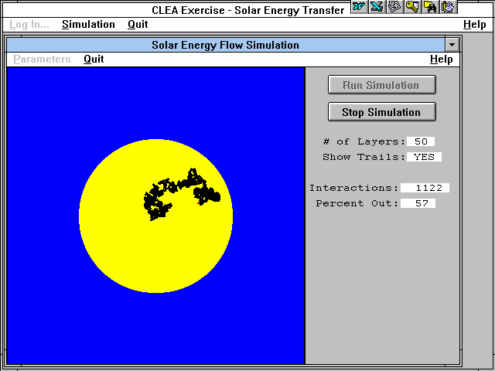

Figure 3
Solar Energy Flow Simulation
Choose the # of Layers in the Sun by selecting # of Layers from the Parameters menu. Click on Run Simulation to begin the experiment. Run the Flow simulation with stars created with 10, 20, 30, 40, 50, and 60 layers. Repeat three times, and average each column. Record the number of interactions in Table 2.

Layers | 10 | 20 | 30 | 40 | 50 | 60
Trial 1
Trial 2
Trial 3
Average

Table 2
Interactions

Plot the average results below. The horizontal X axis should be labeled Layers and run from 0 on the left to 60 on the right. The vertical Y axis should be labeled Average Interactions and run from 0 at the bottom to 6500 at the top.

Does a straight line or a curved line seem to fit your data best? ____________________

Sketch in a best fit line if you can.
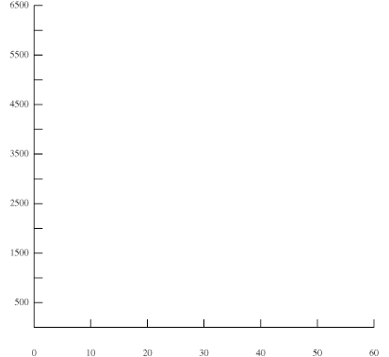

It can be mathematically shown that the number of interactions needed to escape is very nearly n² where n is the number of layers in the model. Calculate n² for the layers you have used. Complete Table 3. Compare the value for n² with your average value, and if the value for n² is higher, write high in the table, if it is lower, write low in the table.

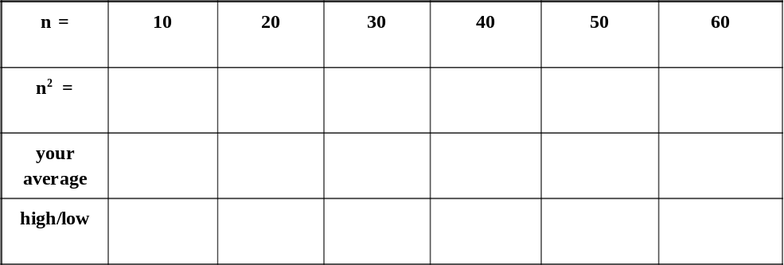

Table 3
n Compared with n²

How do the calculated values of n² compare with the average results from the simulation? If they are different, why?

Click on Return to quit the Flow Simulation exercise.

Exercise 6: Photon Diffusion

From the Simulation menu, select Flow…Diffusion to start.

In Exercise 5 you watched the progress of individual photons as they followed a random walk from the core of the sun to its surface. The process was a statistical one, governed by chance, and you had to repeat the experiment several times to get an estimate of how many interactions, on the average, it takes for a photon to make it to the surface. Suppose that, instead of watching a single photon several times, you could watch several photons all at once.

That is what this simulation permits you to do. You can release from 1 to 1000 photons simultaneously from the center of sun and watch them make their collective trip to the surface. If you wait for them all to come to the surface, you can get a reliable estimate of how many interactions are required to travel through a star of n layers, and the simulated experiment takes far less time than running individual photons through n times.

You can simply redo one of your experiments from Exercise 5 to see how well things agree. Set the simulation for 10 photons and a 50 layer model. Then run the simulation.

What is the average number of interactions required for a photon to reach the surface?

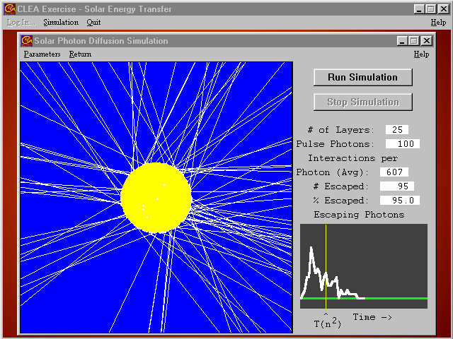
This simulation is not simply a short
way of doing the experiment. It also
illustrates a phenomenon called
diffusion, which means the gradual
“leakage” of photons through a
material, like the solar interior, that
scatters them. Note that all your
photons began their journey at
once—in a brief instantaneous
pulse. Yet because they are scattered randomly on their way out,
some take a long time to escape, and
others a short time to escape. The graph at the lower right of the screen shows (on the Y axis) how many photons make it to the surface at a given time after the initial pulse of photons began at the center (increasing time on the X axis).

Figure 4
Solar Photon Diffusion

Instead of a brief pulse of photons leaving the surface, you see them straggling their way gradually out of the star. The effect is to “muffle” the initial pulse—its energy doesn’t come out all at once, but over an extended period of time.

To illustrate this qualitatively, set the simulation for a 25 layer star and send 100 photons out from the center. Sketch the shape of the curve in figure a. Try this again with a 5 layer star and 1000 photons. Sketch the result in figure b:

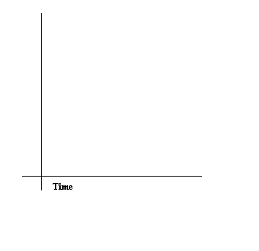
Figure a: 25 layers and 100 photons
Figure b: 5 layers and 1000 photons
T(n²)
T(n²)
T(n²)
T(n²)
Figure a: 25 layers and 100 photons
Figure b: 5 layers and 1000 photons

Are the two curves substantially the same shape? _____ What does this show regarding photon diffusion?

Exercise 7: Questions

Use the speed of light and the radius of the Sun to estimate the escape time for a photon from the center of the Sun if there were no interactions. R_{Sun} = 6.96 x 10⁸ m

c = d / t

In the Sun, it takes several hundred thousand years for a photon released in the core to reach the surface. Using what you have learned in this lab, what causes this difference in escape time from the above calculated escape time?

Exercise 8: Essay Question

Line photons are responsible for the bright lines in an emission spectrum as well as the dark lines in an absorption spectrum. How can this one type of photon give rise to two strikingly different spectra? Write an essay carefully explaining how this is possible. Use diagrams to clarify you argument and consult Kirchhoff’s Laws in the text. Discuss both the journey of the line photon and the method of detecting it.

If you are curious or would like to calculate the wavelength (in meters) by hand, the equation is: l=lc/E Where λ = Plank’s constant = 4.14 x 10 -15 eV second, c = speed of light = 3 x 10 8 meters/second E = energy of the photon in electron volts

