Name:

Lab Partner:

Astrometry of Asteroids
Student Manual
A Manual to Accompany Software for
the Introductory Astronomy Lab Exercise
Edited by Lucy Kulbago, John Carroll University
Edited by Brad Knockel, CNM Community College, 2015

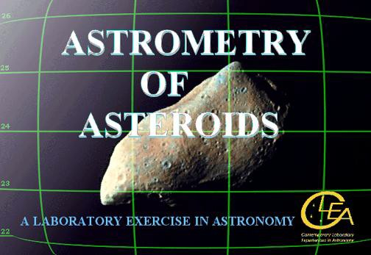

Department of Physics Gettysburg College Gettysburg, PA

Telephone: (717) 337-6028 Email: clea@gettysburg.edu

Contents
Goals 3
Introduction 4
Operating the Computer Program 9
Part I Finding an Asteroid 9
Part II Measuring its’ Position 13
Part III Calculating Angular Velocity 19
Part IV Measuring Distance using Parallax 22
Part V Tangential Velocity of Asteroid 1992 JB 25
Questions 26
Optional Activity 28
References 28

Overall
Goals

You should be able to understand how moving objects can be discovered on images of the sky.

You should understand the fundamentals of using the equatorial coordinate system of right ascension and declination to locate objects on the sky.

You should understand how reference stars of known coordinates can be used to interpolate the coordinates of unknown objects.

You should appreciate the way in which astronomers measure parallax and use it to determine the distance to objects in the solar system and beyond the solar system.

Specific

If you learn to
Display CCD images of the heavens using an astronomical image display program.

Blink pairs of images, and learn to recognize objects that have moved from one image to the next.

Call up reference star charts from the Hubble Guide Star Catalog (GSC) stored on the computer.

Recognize and match star patterns on the GSC charts against the stars in your image

Measure the coordinates of unknown objects on your images using the GSC reference stars.

You should be able to
Find asteroids on pairs of CCD images.

Measure the angular velocity of the asteroid in arcseconds per second.

Measure the parallax of an asteroid seen from two sites on opposite sides of the US.

Use the parallax to determine the distance of an asteroid, using the same technique astronomers use to measure the distance of stars.

Use the distance of the asteroid and its angular velocity to determine its tangential velocity.
Useful Terms You Should Review in Your Textbook

Angular Velocity | AU | Degrees | Parallax | Universal Time | Minutes
arcminutes | Blinking | Hours | Proper Motion | arcseconds | Seconds
Asteroids | Coordinates | Magnitude | Right Ascension | Declination

Introduction

Astrometrical Coordinate systems and the Technique of Astrometry

This lab involves the measurement of precise star positions, a technique called astrometry, which is one of the fundamental tools of astronomers. Astrometry, of course, enables us to make charts of objects in the sky, assigning two numbers or celestial coordinates to each object so that we can easily locate it. If you’ve ever used a roadmap or a map of the world, where two coordinates are used to mark the positions of cities and mountains, you know the usefulness of coordinate systems.

Astrometry also helps astronomers measure the changes in positions of objects in the heavens. One of these changes, called annual parallax, enables astronomers to measure the distances to some stars. Parallax is a semi-annual wobble in the position of a star caused by changing perspective as the earth circles the sun.
Another change, called the proper motion of a star, is a continuous drift across the sky caused by the motion of the star itself with respect to us.

By using computers to measure the positions of stars on digital images of the sky, astronomers determine the coordinates of objects to high precision. Even the relatively simple program you will be using in this exercise can pinpoint objects to better than 0.1 arcseconds, which is about the diameter of a dime viewed from a distance of 20 kilometers. This is not high enough precision to measure the parallax of most stars because most stars are too far away, and therefore have an extremely small annual parallax. So we have chosen to demonstrate astrometric measurement using asteroids, those small rocky planets that orbit the sun—most of them between the orbit of Mars and Jupiter. You will be able to measure the parallax and the orbital motion of asteroids quite easily, and the techniques you learn here are applicable both to asteroid work and to the study of the positions and motions of the stars.

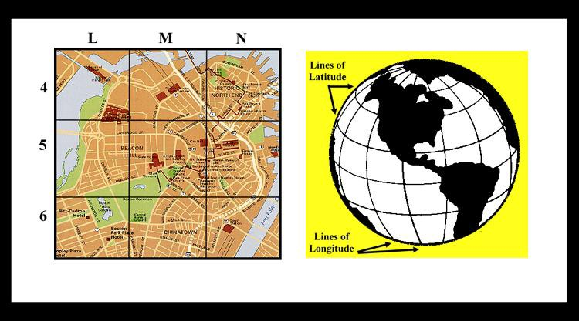
The Notion of an Astronomical Coordinate System

Figure 1 Coordinate Systems

How do astronomers know where a star is in the sky? They use the same method we use here on earth to specify the position of a city on the globe or a street on a map of the city: they give two numbers, called the coordinates of the star, that enable us to pinpoint the object. Imagine the sky covered with a grid of imaginary lines, labeled with numbers. To say that a star is at (X,Y) in the sky, is just like saying a city is at longitude 77 west, latitude 40 north, or that a street is at L, 5 on a map. To find the city, you just look to see where the longitude line labeled “77 west” intersects with the latitude line labeled “40 north ,” and there it is. To find the street, you just look to see where line L intersects line 5 on the map. Two coordinates are all that is needed since the surface of the earth, the city map, and the sky, all appear two dimensional to the observer.

The Equatorial Coordinate System: Declination and Right Ascension

Positions are always measured with respect to something. For instance, latitude and longitude are measured with respect to the earth’s equator and the Greenwich meridian. Coordinates on a piece of graph paper are measured with respect to the corner or to the origin of the graph. The coordinates that are commonly used to specify star positions in astronomy indicate the star’s position with respect to the celestial equator, an imaginary line in the sky that runs above the earth’s equator, and this system is therefore called the equatorial coordinate system. The two coordinates in the equatorial system are called Declination and Right Ascension.

The lines of declination are like lines of latitude on the earth, and are designated by their angular distance north or south of the celestial equator, measured in degrees (°), arcminutes ('), and arcseconds ("). There are 360 degrees in a circle, 60 minutes in a degree, and 60 seconds in a minute. A star with a declination of
+45° 30' lies 45 degrees, 30 minutes north of the celestial equator; negative declinations are used for an object south of the equator.

Right ascension lines are like lines of longitude on the earth, running through the north and south celestial poles perpendicular to the lines of declination. They designate angular distance east of a line through the vernal equinox, the position of the sun when it crosses the celestial equator on the first day of spring. Right
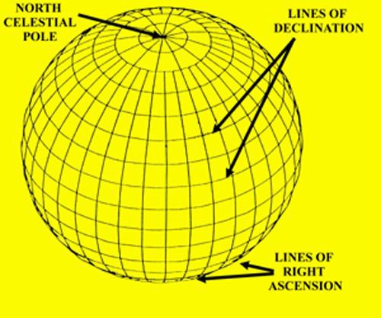
ascension is measured in hours ( H ), minutes ( m ) and seconds ( s ). This may sound strange, but an hour of right ascension is defined as 1/24 of a circle, so an hour of right ascension is equal to 15 degrees.
Figure 2
The Equatorial Coordinates
There are 60 minutes in an hour, and 60 seconds in a minute of right ascension. A star with a right ascension of 5 hours would be 5 hours, or 75 degrees, east of the line of right ascension (0 H ) that runs through the vernal equinox.
There are many catalogs of objects in the heavens which list their right ascensions and declinations. It’s impossible to list all the stars in the sky, so a catalog usually contains stars that are selected by astronomers for a particular purpose. One of the most important

catalogs is called the FK5 Catalog, because it is one of the fundamental catalogs used as a reference for measuring the positions to other stars in the sky (see the next section of this manual). The FK5 Catalog contains only 3522 stars, all of them rather bright. The right ascension and declination of the stars in the FK5 Catalog have been especially carefully measured and re-measured so that they can be relied upon as standard reference points for the measurement of the positions of other objects in the sky.

Another useful catalog which we shall use in this exercise is the Hubble Space Telescope Guide Star Catalog, (GSC). The GSC lists almost all the stars in the sky that are brighter than apparent magnitude 16, which is almost ten thousand times fainter than the faintest star you can see with your naked eye. There are coordinates of almost 20 million stars in the GSC, so many that the full catalog requires two CD-ROMs to hold it. The GSC has been one of the most useful catalogs for astronomers in recent years. There are so many stars in it, scattered all over the sky, that you can practically count on having several GSC stars with known coordinates anywhere you look in the sky. On the other hand, there are so few stars in the FK5 Catalog, that it’s rare that a FK5 star will be in the same direction as an object of interest.

In this exercise, you’ll only be looking at a few specific spots in the sky . To save room on your computer, we’ve extracted only part of the GSC and stored it on your computer for use in this exercise.

The Technique of Astrometry: Finding the Coordinates of Unknown Objects

The lines of right ascension and declination are imaginary lines of course. If there’s an object in the sky whose right ascension and declination aren’t known (because it isn’t in a catalog, or because it’s moving from night to night, as a planet or asteroid does), how do we find its coordinates? The answer is that we take a picture of the unknown object, U, and surrounding stars, and then interpolate its position from that of other nearby stars whose equatorial coordinates are known. The stars of known position are called reference stars or standard stars.

Suppose, for instance, that our unknown object lay exactly halfway between star A and star B. Star A is listed in the catalog at right ascension 5 hours 0 minutes 0 seconds, declination 10 degrees 0 minutes 0 seconds. Star B is listed in the catalog at right ascension 6 hours 0 minutes 0 seconds, declination 25 degrees 0 minutes 0 seconds. We measure the pixel positions of stars A and star B and U on the screen and find that U is exactly halfway between A and B in both right ascension (the x direction) and declination

(the y direction). (See Figure 3 below).
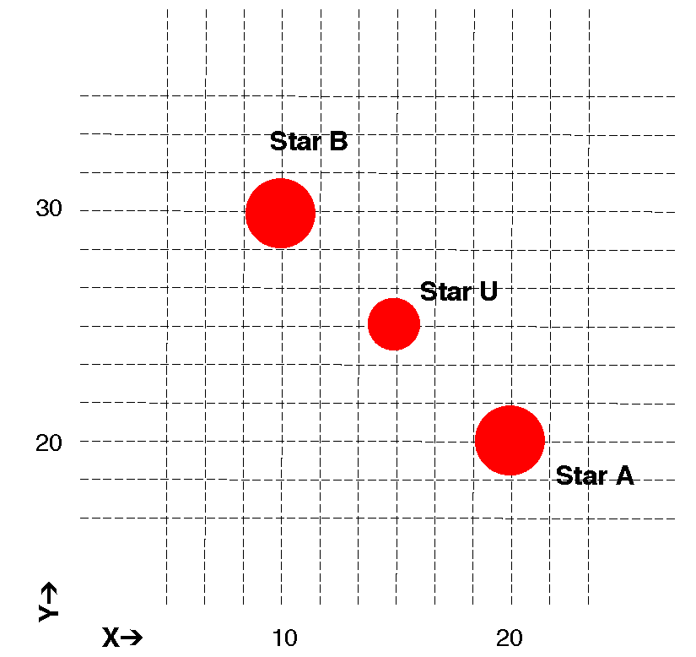
Figure 3 Determining the Coordinates
of an Unknown Object
We can then conclude that the right ascension of the unknown object is halfway between that of A and B, or 5 hours 30 minutes 0 seconds; and the declination of the unknown object is halfway between that of A and B, or 17 degrees 30 minutes 0 seconds. This is outlined in the table below. If the unknown object isn’t exactly half- way between the two known stars, the interpolation is a bit more complicated. In fact, in practice it’s a bit more involved largely because the image of the sky appears flat and, in actuality, the real sky is curved. But it is not difficult to write easy to use software that will do the mathematics for you, and the program we supply does just that. To measure a unknown object’s position from an image, the software will instruct you to choose at least three stars of known coordinates (for best results choose more). Then indicate the location of the unknown object by clicking on it. The computer performs what is called a coordinate transformation from the images on the screen to the equatorial coordinates, and prints out a solution showing you the coordinates of your unknown object.

The software we provide can, in principle, calculate coordinates with a precision of about 0.1 seconds of arc. That’s approximately the angular diameter of a dime seem at distance of about 20 miles, a very small angle indeed.

Star | Right Ascension | Declination | X Position on Image | Y Position on Image
Star A | 5h 0m 0s | 10o 0’ 0” | 20 | 20
Star B | 6h 0m 0s | 25o 0’ 0” | 10 | 30
Unknown Star U | ? | ? | 15 | 25

The Problem of Finding Asteroids

In this exercise you will be using images of the sky to find asteroids and measure their positions. Asteroids are small rocky objects that orbit the sun just like planets. They are located predominately between the orbit of Mars and Jupiter, about 2.8 Astronomical Units from the sun. Asteroids do orbit closer to the sun, even crossing the earth’s orbit. Occasionally an earth-crossing orbit, may even collide with the earth.
Hollywood movie producers have frequently used an asteroid collision as a plot for a disaster movie. The danger is real, but dangerous collisions are very infrequent.

Most asteroids are only a few kilometers in size, often even less. Like the planets, they reflect sunlight, but because they are so small, they appear only as points of light on images of the sky. How then can we tell which point of light on an image is an asteroid, and which points are stars?

The key to recognizing asteroids is to note that asteroids move noticeably against the background of the stars because an asteroid is orbiting the sun. If you take two pictures of the sky a few minutes apart, the stars will not have moved with respect to one another, but an asteroid will have moved. (See figure 4). It’s hard to see the forest for the trees, however. Often there are so many stars on a picture that you can’t easily remember the pattern when you look at another image, and therefore you can’t easily tell which dot of light has moved. Computers come to the rescue again! You can load and display simultaneously two images of the sky that were previously taken with a telescope. You then instruct the computer to switch the display quickly back and forth from one image to another, a technique called blinking. If you are careful to line up the stars on the first image with the stars on the second image before you blink the two images, the only object that will to change will be the asteroid, which will appear to jump, making it easy to spot. Our computer program enables you to easily align the stars on two images and then blink back and forth, making asteroids jump to your attention.
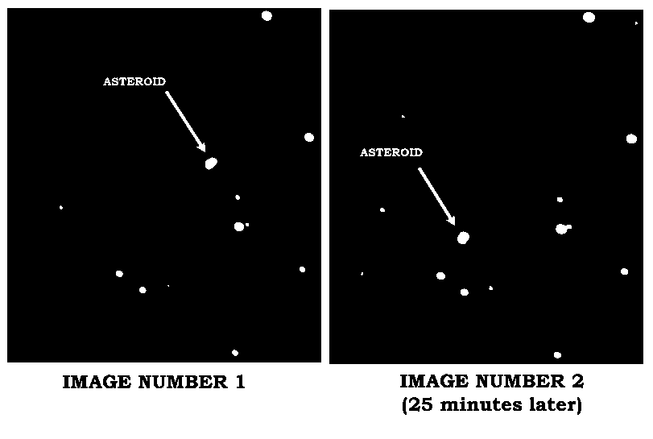
Sometimes the asteroids will be faint; other times there will be spots or defects that appear on one image and not on another. These spots can mislead you into thinking that something has moved into the second image that was not there in the first. So even with the ease of blinking, you should carefully inspect the images, in order to pick out the object (or objects) that really move from a position on the first image to a new position on the second. Seeing the asteroid continue its trend of motion in a third image can confirm your identification.

Figure 4 Finding the Asteroid
Figure 4
Finding the Asteroid

Once you’ve identified an asteroid on a picture, you can then get the computer to calculate its coordinates by measuring its position with respect to reference stars (stars of known coordinates) on the screen.
Comparing an asteroid’s position at particular time with its position at some other time enables you to calculate the velocity of the asteroid, as we will see later in this exercise.

The Principles of Parallax

Measurement of precise positions makes possible one of the most powerful methods astronomers have of measuring the distances to objects in the sky, a method known as parallax. Parallax is the most direct way astronomers have of measuring the distances to stars.

The parallax of an object is its apparent shift in position when you view the object from two different vantage points. It’s commonly used on the earth to measure the distance across a wide river (see Figure 5 below). You view a tree from two vantage points on the opposite shore. You
carefully measure the distance between the two vantage points, called the baseline, B, and the angle between the two lines of sight to the tree, parallax angle designated as Θ. Using trigonometry, you can find the perpendicular distance across the river. Since the distance, D, is one side of a right triangle, the opposite
angle of which is Θ/2, and the adjacent side of which is B/2, the distance across the river can be represented as

D = B/2 _
tan ( Θ/2)

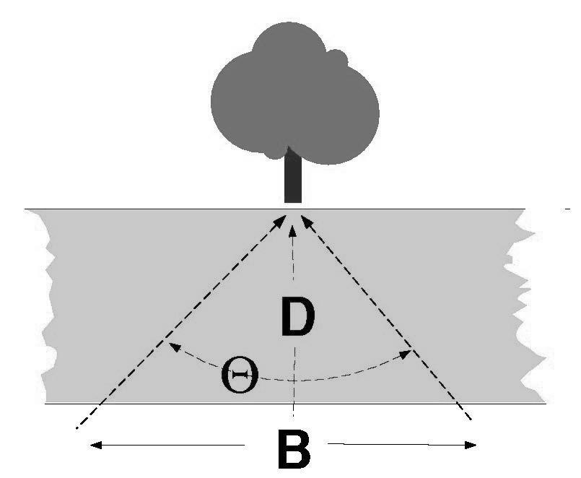
In general, if you can measure the parallax, Θ, of an object as measured from two points separated by a baseline, B, you can measure its distance.

Figure 5 Parallax of an Object

In astronomy, a commonly used baseline is the diameter of the earth’s orbit and the parallax we measure is due to the shift in vantage point as the earth orbits the sun. If we view a nearby star from opposite sides of the earth’s orbit, and measure its position against a background of distant stars, we will see that it appears to move. For example, its equatorial coordinates measured in June, when the earth is at one side of the sun, will be different from its position in January when the earth is at the other side of the sun (see Figure 5).
The further the star, the smaller the parallax. Even the nearest stars have parallax shifts of less than a second of an arc, hard to see and hard to measure. However, astronomers have been able to measure the parallaxes of over a hundred thousand stars using sophisticated techniques and a special satellite called Hipparchos.

It is also possible to measure the distance to asteroids using parallax too. Because asteroids are closer, their parallax is larger, and we can even use a short baseline - like the diameter of the earth. Viewed from two points on the earth, asteroids show a very noticeable parallax, as you will see in Part IV of this exercise.
Measuring the parallax of asteroids using astrometry is a useful exercise for showing us how the much smaller parallax of stars is measured in practice.

Operating the Computer Program

Overall Strategy

- Login and enter student information.

- Access and browse through the Help Screens.

- Become familiar with the procedure of loading and displaying CCD images, and learn how to blink images in order to identify which object is the asteroid.

- Using the GSC and the technique of blinking the image, measure the equatorial coordinates of the asteroid.

- Determine how fast the asteroid is moving and its distance from earth by using the data you have collected on the asteroid’s position in conjunction with simple trigonometric formulae.

Starting the program

Under a typical installation, you will find Astrometry of Asteroids under CLEA Exercises in the Programs section of the Windows Start menu. If this is not the case, consult your instructor. When the program starts, the CLEA logo should appear in a window on your screen. Select Login > under the File menu. Fill in the form that appears. When you have completed the form and clicked OK, the opening screen of the Astrometry of Asteroids lab will appear.

Accessing the HELP Files
You may, at any time, select Help from the menu. Within Help…Topics, there are five options that you can select: Login, Files, Images, Reports, and Close the Program. LogIn informs you of the initial steps required to begin the program. Files provides information on the types of files used in this exercise and how to load these images. Images explains how to retrieve and modify images, print images, blink images, and measure images. Using the Help…Topic…Reports menu choice will show you how you can review your observational data and also how to compute projected baselines. Close the Program gives the procedure on how to exit the program as well as a reminder for any unsaved data. There is no user help for this program; therefore the User option is disabled. About This Exercise displays the title and version number of the program as well as the copyright information.

Part I Finding Asteroids by Blinking Images

This software includes a series of images of a region of the sky, about 4 arcminutes square, in which astronomers were searching for a faint earth-approaching asteroid designated 1992JB. The problem is to recognize the asteroid, which as the name suggests (aster-oid = “starlike”), looks just like a star.

In the first part of this exercise you will examine the images to find a moving object, the asteroid 1992JB. The technique you will use is called blinking. Using 2 stars on each image as reference points, you can align the images electronically in the computer. After alignment, whenever you turn on the blink feature, the computer will quickly switch its display from one image to another. Stationary objects like stars will not appear to change position, but objects that have moved from one image to the next will appear to jump, drawing your attention to them. You can thus identify which starlike object is, in fact, the asteroid.

Procedure for Part I

- Let’s look at one of the images. From the menu bar, choose File… Load Image Files… Image 1. A directory listing showing you a list of files appears. From this list, select 92jb05.fts, and click Open to load it.

  - The computer will show you the progress of the loading and creating a screen for display and then write the name of the file on the screen to let you know it has successfully loaded Image 1.
  - The image has been loaded, but is not yet displayed. To display it, select Images on the menu bar, then choose View/Adjust… Image 1 from the pull-down menu. A window showing the image 92JB05 will appear on your screen.

Main Window

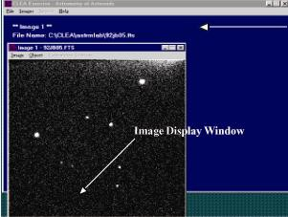

Figure 6
Image Display Window

  - The image is oriented with west to the right and north to the top. All of the dots you see on the image are distant stars except one, which is the asteroid. We’ll make a chart of the image and mark the asteroid when we discover it. In the blank space located on the following page, make a freehand sketch of the image 92JB05. Try to pay attention to the details—draw it to scale and try to make it fit in the space.

NORTH

EAST

Figure 7
Your Freehand Sketch of the Image

- Now let’s find the asteroid. Load as before, but this time choose File…Load Image Files …Image 2 from the main program window (which appears blue not black as in the Image 1 window). From the list of images, select 92jb07.fts, and click Open to load it.

NOTE: The program can load up to four image files for blinking purposes, but for first-time users we recommend blinking only two at a time. Thus you will be loading images only in the Image 1 and Image 2 slots. If at some point you wish to blink more than two images, try File > Load Image Files > Multiple Load. Then use the CTRL key to select multiple images.

You can display this image in its own window by using the Images. ..View/Adjust…Image 2 selection on the menu bar. Since 92JB07 was taken 10 minutes after 92JB05, the asteroid will have moved. But it may not be immediately obvious which star-like object is out of place, even when you compare the images side by side.

So we blink the images, first aligning them so they coincide, and then using the computer to flip from one image to the other. Here are the steps we use to blink the images.

  - We must first align the images. From the main menu bar located on the blue window, choose
Images…Blink. You will see one window now, displaying just Image 1.

  - At the bottom right, a small instruction box asks you to click on an alignment star, which the computer can use to align the two images. If possible, you should try to choose two stars that are on opposite sides of the picture to achieve best results. (The best combination is a pair of diagonally opposite stars.) Choose one of the brightest ones, click on it, and note it for your own reference by writing the number 1 next to it on your freehand drawn chart.

  - Click on Continue in the instruction box, and it will ask you for a second alignment star. (Two stars are needed to account for possible rotation of the images.) Click on this star, record it on the chart above as 2, and click again on Continue.

  - Now you will see Image 2, and you will be asked to identify star number 1 on Image 2. Check your chart, then click on the same star 1 that you chose in Image 1. If you are satisfied, click Continue in the instruction box. You are now asked to identify star 2 and again you click on the same star 2 that you chose in Image 1. Actually, based on your choice of stars in Image 1, the computer will make a good guess as to where the star should be on Image 2. It will draw a box around where it thinks it should be, and if, in fact, it comes close, you need merely click Continue to accept its choice. You’ll find that the computer does this guesswork in many parts of the program, making it easier for you to make measurements quickly.

  - The computer now has all the information it needs to align the images and blink them. All you need to do is click on Blink from the menu bar at the top of the blinking window, and you will see the computer flip back and forth between Image 1 and Image 2 about once a second. The stars will not move, but you should easily be able to pick out the asteroid as the one object that does jump. Be careful when choosing! For example, occasionally a white spot will appear on one image, and not the other. It is not an asteroid, however, but a defect in the picture itself. This is usually caused by radiation—a cosmic ray most often—that exposes a single pixel in the camera during one exposure. You may also notice all the stars brighten and dim, since one image is a longer exposure and therefore brighter. Similarly, the background shade may be lighter in one image than in another. But the asteroid should appear clearly as a smudge of light that changes position from one image to the other.

  - To stop the blinking select Stop from the menu bar. To adjust the rate of blinking slower or faster at your convenience, select Adjust…Blink Rate. The Blink Rate Interval dialog box appears. The blink rate can be adjusted using the slide bar to increase or decrease the rate per msec that the images blink. The range is from 10 to 1000 msec with the default set at 500 msec.

  - To start over, select the Adjust…Field Alignment menu option to choose the alignment stars again.

  - When you have identified the asteroid on Image 1 (92JB05) and Image 2 (92JB07) mark the position of the asteroid with a dot on your chart. On the freehand drawing in Figure 7, neatly label the asteroid’s position on Image 92JB05 with a small 05 and its position on Image 92JB07 with an 07.

- Now continue to find the asteroid on images 92JB08, 92JB09, 92JB10, 92JB12, and 92JB14 by blinking them. You will continue to use Image 92JB05 as Image 1.

To do this, simply select the Load…Image2 menu item, and then Image…Blink to blink the images. You will be prompted to identify the alignment stars on the new image. Continue with images 09-14.

The procedure will then be the same as you followed with image 92JB07 as Image 2. Again, mark the successive positions of asteroid 1992JB by dots labeled 08, 09, 10, 12, and 14 on the chart you made in step 1.

You should note the asteroid is moving in a straight line. Draw an arrow in the space below to show the direction of motion. Don’t forget the orientation of the image is different from what would be found on a traditional land map; see Figure 7.

What direction is this? (North, Northeast, Southeast, etc.)?

Figure 8
Direction of Motion of the Asteroid

Part II

Measuring the Equatorial Coordinates of an Asteroid by Comparing It to Positions of Known Stars in the Hubble Guide Star Catalog

Now that you have identified which object on the images is the asteroid, the next step is to determine the location of the object in the sky by measuring its equatorial coordinates, i.e. the object’s Right Ascension and Declination. The computer can do this by a type of interpolation or “fitting” process, which compares the position of the asteroid on an image with the positions of stars whose coordinates have been previously tabulated in a catalog. The most widely used catalog today is an electronic file called the Hubble Guide Star Catalog (GSC), which was originally created to aid in pointing the Hubble Space Telescope. The GSC, as it is called, was created by measuring star positions on photographs of the sky. It contains coordinates and magnitudes of about 20 million stars brighter than apparent magnitude 16. The GSC is available on two CD-ROMs, but to make it unnecessary for you to insert a CD into your computer, we have selected
part of the GSC and stored it on your computer’s hard drive, where the Astrometry program can access it easily.

For each image of 1992JB, you will determine the coordinates of the asteroid by
  - Telling the GSC the approximate coordinates of the center of the image, so that it can draw a map of the stars with known coordinates in the vicinity.

  - Identifying at least three GSC stars that are also on the image, as reference stars for calculating coordinates on the image.

  - Pointing and clicking on each star on your image that is a reference star, so that the computer knows which star on your image corresponds to a particular reference star in the catalog.

  - Pointing and clicking on a target object with unknown coordinates: the asteroid. The computer then calculates its coordinates with reference to the GSC reference stars you have chosen.

  - Writing the coordinates of the asteroid in the table at the end of this section.

Procedure for Part II

- Let’s measure the position of the asteroid in Image 92JB05. If it is not already loaded into Image 1, use the File…Load Image Files…Image1 menu choice from the main window to load the file. Then choose the Images…Measure…Image1 menu choice. A window will open asking you to confirm the Observation Date and Time. Click OK. A second window will open asking you to confirm the coordinates for the center of the field with those in Table 2 on page 18. Set the Field Size at 8 arcminutes. The default value for the magnitude limit is 20. When you have entered the field center information, click OK. This second window will only open the first time through this measurement. If you should need to change the information, you will need to cancel the reference parameters by going to File….Clear Images/Ref Fields…Reference Fields Only.

- The computer will now search for stars in this region in the GSC, and will draw a star chart, based on the GSC coordinates in a window on the left-hand side of the screen. It will display the Image 1, 92JB05, in a window on the right-hand side of the screen. (See Figure 9 on the following page). The Image will show more stars than the GSC map, partly because one of the “stars” is the asteroid, and also because the GSC only includes stars brighter than 16th magnitude, and some of the stars in your images are fainter than that. However, you should see a distinctive pattern of at least three stars in the GSC chart that you can match to the brighter stars on your image. Note that the scale of the chart will not match the scale of the image.

- When you see the match, you will want to identify it. First sketch all the reference stars from the reference star window on the left in the space below, then label the three you will use 1, 2, and 3.

Figure 9
Sketch of Reference Stars

- Now you will tell the computer which ones you’ve chosen. Using the mouse, click on reference star number one in the left window (the GSC map). A dialog box will open at the bottom of the page, identifying the GSC data on that star; simultaneously the computer will draw a colored box around the reference star on the chart. (Figure 10)

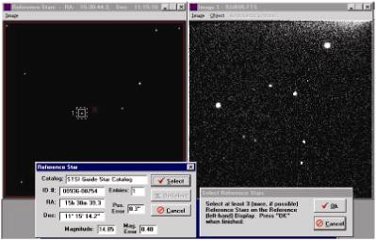

Figure 10 Selecting Reference Stars

Record the ID#, RA, and Dec of each reference star in Table 1.

Click select in the dialog box at the bottom of the page to set your first reference star. Repeat the process for reference star 2, etc. until you have marked as many reference stars as you can see on both the GSC chart and image 92JB05. (You need to identify and mark at least 3, well spaced over as wide an area of the image as possible, for best results.).

Reference Star Coordinates

Reference Star | ID # | RA | Dec
# 1
# 2
# 3

Table 1
Table of Reference Star Coordinates

- When you have selected at least 3 reference stars and marked them, go to the Select Reference Stars dialog box that is in the bottom center of the screen and click OK to tell the computer you’re finished selecting stars. If you’ve only chosen 3, the computer will warn you that more reference stars would give you better results, but if 3 is all you could choose, assure the computer by clicking NO, you don’t want to choose any more.

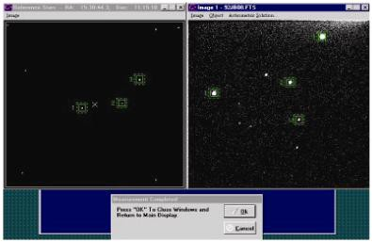
- You will now be asked to point to reference star 1, then star 2, etc. in the right window—Image 92JB05. Click on each star in turn, making sure to match it with the reference star you’ve selected on the GSC chart, and click OK on each to signal you’ve picked the right star. The computer will start to second-guess you— after 2 stars have been identified, it will be able to tell approximately where star 3 is, and if the computer has done a good job (Star 3 is anywhere inside the colored box the computer draws on the screen), you need only click OK to accept its choice.

Figure 12 Identification Window

- When all the reference stars have been identified on your image, the computer will then ask you to point and click on the “unknown” or “target” star—the asteroid. If you click OK after choosing this star, the computer will have enough information to calculate the coordinates of the target star with respect to the reference stars. A small text window will open on the left side of the screen displaying the right ascension and declination coordinates of your target object. Write these down in Table 3 on page 18 at the end of this section. We’ve already written down the measured right ascension of the asteroid 92JB05 to get you started.

- After you’ve written down the data, click on OK in the center box at the bottom to accept the solution. Then when the computer asks if you want to record the data, click Yes.
Finally click OK to record your measurement on a data file. You can view this report form from the Report menu item on the main window at any time for your own reference, and you may want to print it out later when you have added all the other measurements to it.

- Now use the File…Load Image Files…Image1 menu choice on the main window, along with the Image…Measure..Image1 menu choice, to measure the asteroid position in images 92JB07, 92JB08, 92JB09, 92JB10, 92JB12, and 92JB14. You will proceed just as you did above, recording your data both on this worksheet and on the computer. You will note that the computer quickly learns the setup you are using—it will know what reference stars you chose the first time, and outline them on the GSC window the next time through. You will still have to match the stars on your image with reference stars on the GSC, and you will, of course, have to show the computer where the asteroid is, since it moves from one image to the next.

The measuring process should be rapid. If you need to change any of the field settings, you can change them by using the File…Clear Images/Ref. Fields menu choice, which clears all the images from computer memory and starts over.

- When you have recorded the positions of the asteroid on all the images, you are ready to proceed to the Part III.

The asteroid is moving in a straight line (over the small field of this image—it’s actually going in an orbit around the sun, of course). Therefore you should note a smooth change in the numbers from beginning to end—a regular increase in right ascension (if it’s moving eastward) or decrease (if its moving westward) and a regular increase or decrease in declination (depending on whether it’s moving northward or southward). Re-measure any images that seem to be in error.

Table 2 Information on Images
Search images for 1992 JB
All images taken on May 23, 1992 at the National Undergraduate Research Observatory, using the Lowell Observatory 0.8 m f/15 telescope.
Camera: 512 x 512 Tek Chip with 28 micron pixels
FILE NAME | RA (2000) of  image center (h m s) |  |  | DEC (2000) of  image center  (h m s) | TIME (UT) of  mid-exposure (h m s) |  |  | Exposure length (s)
92JB05 | 15 | 30 | 44.30 | 11 15 10.4 | 04 | 53 | 00 | 30
92JB07 | 15 | 30 | 44.30 | 11 15 10.4 | 05 | 03 | 00 | 120
92JB08 | 15 | 30 | 44.30 | 11 15 10.4 | 05 | 09 | 00 | 30
92JB09 | 15 | 30 | 44.30 | 11 15 10.4 | 06 | 37 | 30 | 180
92JB10 | 15 | 30 | 44.30 | 11 15 10.4 | 06 | 49 | 00 | 30
92JB12 | 15 | 30 | 44.30 | 11 15 10.4 | 06 | 57 | 00 | 120
92JB14 | 15 | 30 | 44.30 | 11 15 10.4 | 07 | 16 | 00 | 30

Note: Some of the above data may differ from the data that appears in the computer window when the file is loaded. You do not need to correct the information stored in the software and you may just click OK.

Table 3
Measured Equatorial Coordinates

COORDINATES OF ASTEROID 1992JB
MAY 23, 1992

File Name | Time (UT) | RA(h,m,s) | Dec (° ' " )
92JB05 | 04 53 00 | 15 30 38.70
92JB07 | 05 03 00
92JB08 | 05 09 00
92JB09 | 06 37 30
92JB10 | 06 49 00
92JB12 | 06 57 00
92JB14 | 07 16 00

Note: All the values for RA should be approximately the same.

Part III

The Angular Velocity of Asteroid 1992JB

How fast is 1992JB moving? We can calculate its angular velocity in arcseconds per second of time using data taken in Part II of this exercise (See Table 3). The procedure we follow is to subtract the asteroid’s starting position on image 92JB05 from its ending position on image 92JB14, and divide by the number of seconds between the starting image and the ending image. We express this mathematically as
μ = Δθ
Δt
where μ is the angular velocity of the asteroid, Δθ is the angular distance it moved, and Δt is the time that elapsed.

For your guidance in these calculations, approximate values appear in parenthesis beside some key answers. These are ballpark figures given to help reduce calculator errors. You should record your calculated values even if they are not near the given values.

Procedure for Part III SHOW ALL YOUR WORK
- Measuring the elapsed time
  - Record the time when image 92JB14 and 92JB05 were taken. (These values are recorded in Table 3, Measured Equatorial Coordinates, in Column 2 Time (UT).)

Time of image 92JB14: hours minutes seconds Time of image 92JB05: hours minutes seconds
- Convert the hours to seconds to make subtraction easier. (Note: Multiply minutes by 60 and hours by 3600 and add all the values together.)

Time of image 92JB14: seconds Time of image 92JB05: seconds
- Subtract the time when image 92JB05 was taken from the time image when image 92JB14 was taken.

Time elapsed between 92JB14 and 92JB05 Δt = seconds (8500)

Measuring the angular distance traveled by 1992JB

In order to calculate the angular distance traveled, , we use the Pythagorean theorem, which states that:

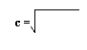

a2 + b2
As illustrated in Figure 13, because right ascension and declination are perpendicular coordinates, we can find the total angle moved using this mathematical relationship derived from the Pythagorean theorem.

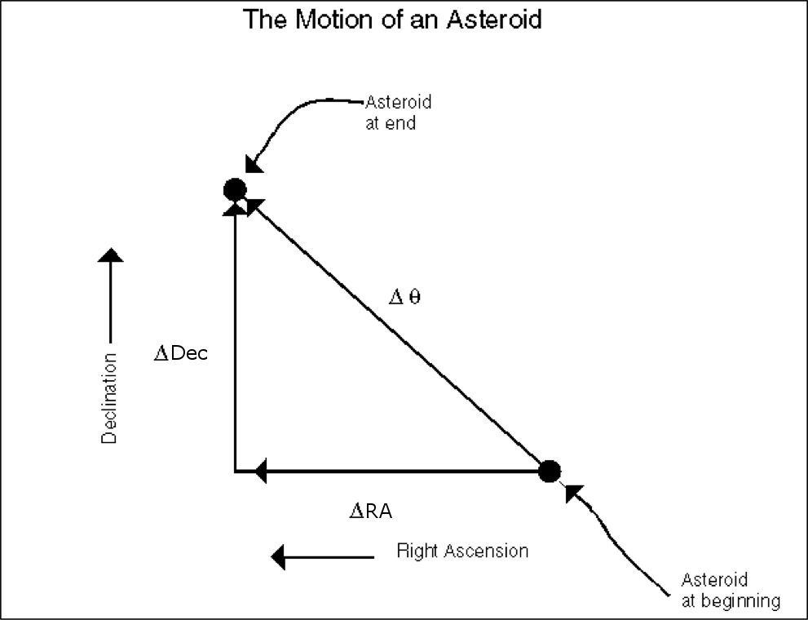

Figure 13
The Mathematical Illustration of the Motion of an Asteroid

Using Figure 13 as a guide, if we let ΔRA represent the change in the number of seconds in right ascension, and ΔDec represent the change in the number of arcseconds moved in declination, then using the relationship expressed by the Pythagorean theorem, we can construct the following equation to determine the total angle moved.
Δθ =
(ΔRA)2 + (ΔDec)2

- Record the values for the declination of images 92JB14 and 92JB05 below. (These values are recorded in Table 3, Measured Equatorial Coordinates.)

Declination of asteroid on 92JB14 ° ' " Declination of asteroid on 92JB05 ° ' "
- Convert to arcseconds just as you converted to seconds in 1-b above. (That is multiply ' by 60 and
° by 3600 and add all the values together.)

Declination of asteroid on 92JB14 "

Declination of asteroid on 92JB05 "

- Subtract to find the change in declination

ΔDec " (100)

- We will need Dec in degrees in step k, so we will convert it to degrees now, by dividing the arcseconds by 3600.

Dec ° (11)
- Record right ascension values for each image below from Table 3, Measured Equatorial Coordinates.

Right Ascension of asteroid on 92JB14 h min sec Right Ascension of asteroid on 92JB05 h min sec
- Convert to seconds:

Right Ascension of asteroid on 92JB14 seconds Right Ascension of asteroid on 92JB05 seconds
- Subtract to find the change in right ascension:

 
ΔRA seconds
Does your answer appear to agree with step h? If not, see if you can find what you did wrong.

BUT WAIT! We’re not done yet—1 second of RA is 15 arcseconds times the cosine of the declination. (Remember the RA lines come together at the poles, and so there are smaller angles between them at high declination. Multiplying by the cosine of the declination adjusts for this physical change). Use Declination for the image center, any of the values on Table 3 will do, and you can round them to the nearest degree for simplicity! Note: Make sure your calculator is in Degrees Mode.

ΔRA(“) = ΔRA(sec) x 15 x cosine(Declination( °)) = "

- Using the Angular Distance Traveled Formula, calculate Δθ, using ΔRA in arcseconds from step m and ΔDec in arcseconds from step h .

(ΔRA(“))2 + (ΔDec(“))2

 

= " (100)

4. Calculating the angular velocity of Asteroid 1992JB on May 23, 1992:

μ = Δθ
Δt

- Calculate μ by using Δθ from step l and Δt from step c.

μ = "/second. (0.01)

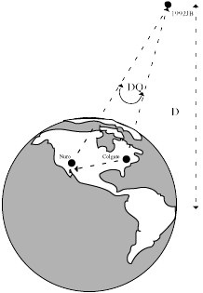
Note: We’ve only calculated the angular (apparent) velocity of the asteroid. We need to know its distance to calculate how fast it’s actually traveling in km/second. We will calculate the distance of 1992JB in the next section, using the method of parallax.

Part IV

Measuring the Distance of Asteroid 1992JB by Parallax: In this section we’ll use our new-found skill in measuring coordinates to
determine the parallax of asteroid 1992JB. For this purpose, we took two images of 1992JB simultaneously from observatories at opposite sides of the United States. One image, you have already seen: Image 92JB12, which we have also stored under the name ASTWEST. It was taken by
Dr. Laurence Marschall using a 0.8m diameter telescope at the National Undergraduate Research Observatory in Flagstaff, Arizona. The other image ASTEAST was taken by Dr. Thomas Balonek using an 0.4 m telescope at the Foggy Bottom Observatory of Colgate University in Hamilton, New York.

Figure 14 Parallax Observations
1992JB

Time of Observation at Both Sites
06 57 00 UT 23 May, 1992
Site | Latitude | Longitude |  | Image File | Exposure
Foggy Bottom Observatory, Colgate University  Hamilton, NY | 42° 48' 59.1" | W 75° | 31'59.2" | ASTEAST | 120
National Undergraduate Research Observatory Flagstaff, AZ  (Telescope Operated byLowell Observatory) | 35° 05' 48.6" | W111° | 32' 09.3" | ASTWEST | 120

Because the asteroid is much closer than the stars, it appears in a different position on the two images with respect to the background stars. This is called its parallax. By measuring the position with respect to

reference stars on both pictures, we can determine the parallax, which is just the angular difference Δθ, in arc seconds, between its position on the image taken from the eastern site and from the western site. Using simple trigonometry (see Figure 5 as the example), if B, the baseline, is the distance between the two telescope sites in kilometers, then :

Dist. To the Asteroid = 206,265 (B /  Δθ)
Using our program, then, the measurements can be done rather quickly.

Procedure for Part IV

Loading the Images
Load ASTEAST as Image 1. Load ASTWEST as Image 2. Display the two images side by side for comparison. Note that the two cameras had different sensitivities (the east-coast telescope was smaller), and had CCD chips of different dimensions, so the images don’t look quite the same. But the same reference stars are visible on both images. Find asteroid 1992JB again on each image (you can refer to your chart in part 1—remember ASTWEST is 92JB12)

Look at image ASTWEST. Compared to its position on ASTEAST, does 1992 JB look further to the east or further to the west with respect to the background stars?

Using words and/or a diagram, try to explain why the position appears to shift, and explain the definition of parallax.

Measuring the coordinates of the asteroid in ASTEAST and ASTWEST
Now using the methods you learned in part 2, measure the coordinates of the asteroid in ASTEAST and ASTWEST. You can use the Images…Measure…Image 1, and Images…Measure…Image2 menu options on the main window. Tabulate your results below.

Measurement of Coordinates fo r ASTEAST and ASTWEST
File
RA (h m s) of 1992JB
Dec (° ' ") of 1992JB
ASTEAST

ASTWEST

Calculating the parallax of 1992JB
The parallax of 1992JB is just the difference between the two positions. We can follow the methods of calculating the angular difference between two positions that we used Part 3. We separately calculate the difference in the declinations and the difference in the right ascensions in arcseconds ( " ) and then find the total angular difference as the square root of the sum of the squares of the declination and right ascension differences.

SHOW ALL YOUR WORK.

    - Express the coordinates of 1992JB on both images in seconds to make subtraction easier (optional):

File
RA (s) of 1992JB
Dec (") of 1992JB
ASTEAST

ASTWEST

    - Express the difference ΔDec in arcseconds: "

    - The Dec will be needed in step e. Copy over your result from page 21 step g.

Dec ° (11)
    - Express the difference ΔRA in seconds: seconds

    - Convert to arcseconds by using the equation (the Declination is derived declination of the asteroid---use the value from any measurements—e.g. table 3—it need only be to the nearest degree)

ΔRA(“) = ΔRA(sec) x 15 x cosine(Declination°) = "

 
    - Calculate the total parallax in arcseconds:

(ΔRA(“))2 + (ΔDec(“))2

Parallax =

 
using ΔRA in arcseconds from step d and ΔDec from step b.

Parallax = " (15)

Calculating the distance of Asteroid 1992JB:

Knowing the parallax of Asteroid 1992JB when seen from the Flagstaff, AZ, as compared to Hamilton, NY, and knowing the projected baseline, i.e. the separation of the two telescopes perpendicular to the line of sight (2874 kilometers), we can use a simple trigonometric formula to calculate the distance of the asteroid

Distance to the Asteroid = 206,265(Baseline/Parallax)

where the baseline and the distance are both expressed in kilometers and the parallax in arcseconds.

- Using this formula, calculate the distance of 1992JB on May 23, 1992 at 06 57 UT.

i. | Distance of 1992JB = km.
ii. | Distance of 1992JB = Astronomical Units. | (0.3)

- Compare these distances with the distance of the Moon, Mars, Asteroid Belt, and Jupiter from Earth. These values can be found in the appendix of your text. If the quantity varies, give the distance when objects are all on the same side of the Sun (for example, Earth to Mars is 0.52 AU).

  - Earth to Moon
km, AU

  - Earth to Mars
km, AU

  - Earth to Asteroid Belt km, AU

  - Earth to Jupiter
km, AU

- How many times further or closer is the asteroid than the moon? .

- Asteroids are classified by their average distance from the sun. Belt Asteroids orbit in the asteroid belt; Trojan Asteroids orbit at the same distance as Jupiter. Near-Earth or Earth Approaching asteroids have orbits that bring them near the earth. What kind of an asteroid do you think this is? Why?

Part V: The Tangential Velocity of Asteroid 1992 JB:

The tangential velocity, V_{t}, of an asteroid is the component of its velocity perpendicular to our line of sight. Again, a simple trigonometric formula lets you calculate its velocity in kilometers/second if you know its angular velocity (μ, in "/sec) and its distance (km). We determined the angular velocity in Part 3 step m and the distance in Part 4 step g,i of this exercise. Then it follows that the tangential velocity is represented as:
Vt = (μ × dist.)/206,265
So using our results, calculate the tangential component of velocity of the asteroid.

Vt = km/sec (3)

QUESTIONS

- There are two perpendicular components of the velocity of the asteroid. One is the tangential component calculated above. What is the second component? Draw the velocity vectors and label both components

- What is the orbital radius of the Earth? What is another name for this distance? Express this distance in both AU and km. Draw a picture of the Earth orbiting the Sun to help you answer this question.

- What is the orbital period of the Earth? Express this answer in both years and seconds.

- Using the information from questions 2 and 3, we can calculate the orbital velocity of the Earth for comparison with the orbital velocity of the asteroid. Velocity can be calculated by using this equation: velocity = distance / time. Using the orbital radius of the Earth, divide the circumference of the Earth’s orbit (2 π ROE) with its orbital period (T) in seconds to determine the earth’s orbital velocity.
VO = 2 π ROE / T

- Would you expect an asteroid to have a lower or higher orbital velocity than the earth? Why? Look at the orbital velocities of planets in our Solar System in an appendix in your text for a pattern on which to base your answer.

- How does this asteroid’s tangential component of velocity compare to the orbital velocity of the earth? Does it follow the pattern of orbital velocities of other objects in the Solar System?

Optional Activity

Use the Astrometry program to analyze a set of image pairs provided by your instructor. (These images pairs are listed in the table below.) For each image pair, blink the images, and try to find an asteroid. Note your findings in the table. If there is an asteroid, measure its coordinates.

Note: Coordinates of standard stars are provided for only one asteroid in the program, therefore you will only be able to determine the coordinates of one asteroid.

Identifying An Asteroid
Image Pair | Asteroid Identified  (yes or no)
A1/A2
B1/B2
C1/C2
D1/D2
E1/E2
F1/F2
G1/G2
H1/H2
I1/I2
J1/J2

References
Laurence A. Marschall, “Coordinates and Reference Systems”, in The Astronomy and Astrophysics Encyclopedia, Stephen P. Maran, ed., New York Van Nostrand Reinhold, 1992, pp. 131-133.

