THE PERIOD OF ROTATION OF THE SUN

Student Manual

A Manual to Accompany Software for
the Introductory Astronomy Lab Exercise
Edited by Brad Knockel, CNM Community College, 2015

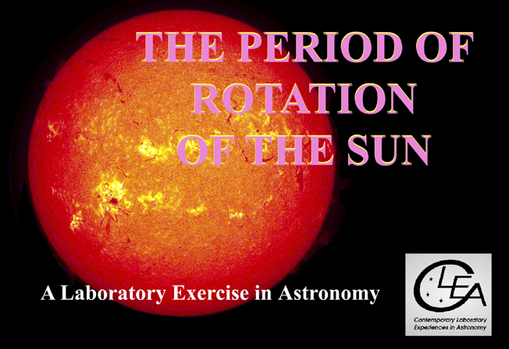

Department of Physics  Gettysburg College  Gettysburg, PA 17325  Telephone: (717) 337-6019  email: clea@gettysburg.edu  Database, Software, and Manuals prepared by:  Laurence Marschall and Glenn Snyder (CLEA PROJECT, Gettysburg College)  and  Jeff Sudol (GONG Project, National Solar Observatory) | Contemporary Laboratory Experiences in Astronomy
Contents

Goals 3

Introduction 4

Overall Strategy: Things to think about when analyzing the pictures of the Sun 7

Calculating the sidereal period of rotation of the Sun from your measurements 8

Equipment 9

A user’s Guide to the Program: The Period of Rotation of the Sun 9

Loading and Displaying Images 10

Animating a Series of Images 10

Measuring the Positions of Spots 11

Recording Data 13

Seeing a Table of Recorded Data 13

Plotting Latitudes and Longitudes of Spots Versus Time 14

Using the Program in the Period of Rotation Exercise 15

The Period of Rotation of the Sun: Discovery Based Procedure (Instructor’s Option) 16

Extra Credit Project: Latitude dependence of the Solar Rotation Rate 17

The Period of Rotation of the Sun: Step-By-Step Procedure (May not be Present if Instructor Opts for Discovery Based Procedure) 18

LEARNING GOALS
- The student should be able to state the direction of rotation of the Sun as seen from the earth.
- The student should be able to state the rate of rotation of the Sun.
- The student should be able to explain how rate of rotation of the Sun can be determined from observations of sunspots.
- The student should be able to describe the appearance of sunspots, the long-term changes in the appearance of sunspots, and the lifetimes of sunspots.
- The student should develop an appreciation of the complexities in interpreting two-dimensional photographs of the three-dimensional Sun as observed from the moving earth.
- The student should develop an appreciation of the difficulty of turning images into meaningful scientific information.

PROCEDURAL OBJECTIVES

If you learn to……

- Use CLEA software to display CCD images of the Sun taken by the Gong Project cameras.
- Measure the positions of sunspots on the pictures.
- Understand the relation between the x and y positions and spherical coordinates on the curved surface of the Sun.
- Determine how fast the longitude and latitude of spots on the Sun change.
- Understand the relation between the angular speed of a spot and the rotation rate of the Sun.
- Understand the difference between the synodic period of rotation of the Sun and the sidereal period of rotation of the Sun.

You should be able to……

- Select a series of images with sunspots suitable for measurement.
- View an animation of the images showing the motion of the spots as the Sun rotates.
- Devise a procedure for determining the apparent rotation rate of the Sun by measuring the positions of sunspots.
- Convert the apparent rotation rate of the Sun into the sidereal rate of rotation of the Sun.
- Explore how the rotation rate of the Sun depends on latitude.

USEFUL TERMS YOU SHOULD REVIEW IN YOUR TEXTBOOK AND IN THIS MANUAL
Degrees | Heliographic Coordinates | Julian Day | Latitude | Longitude | Pixels
Photosphere | Revolution | Rotation | Sidereal Rotation Period | Sunspot | Synodic Rotation Period

Introduction

Though there are ancient Chinese records of spots on the Sun seen at sunset, the solar disk is generally too bright, and sunspots too small, to be seen with the naked eye. But sunspots are easily seen using a telescope. Thus it is not surprising that Galileo Galilei, who pioneered the use of the telescope in astronomy, was one of the first to publish a series of observations of sunspots that he made with the telescope in 1613. Galileo was quick to recognize that the spots were markings on the visible surface of the Sun, and that they moved as the Sun rotated. Three of his sketches of sunspots, made on three consecutive days, are seen Figure 1. These sketches clearly show the motion of the sunspots (we have added the arrows to emphasize the motion of one of the spots) Note that the detailed appearance of the spots does appear to change---this isn’t due to imperfect drawing skills on the part of Galileo, but due to the variability in appearance of the sunspots themselves. They grow and shrink in size, and spots last a few weeks at most before fading out.
Figure 1
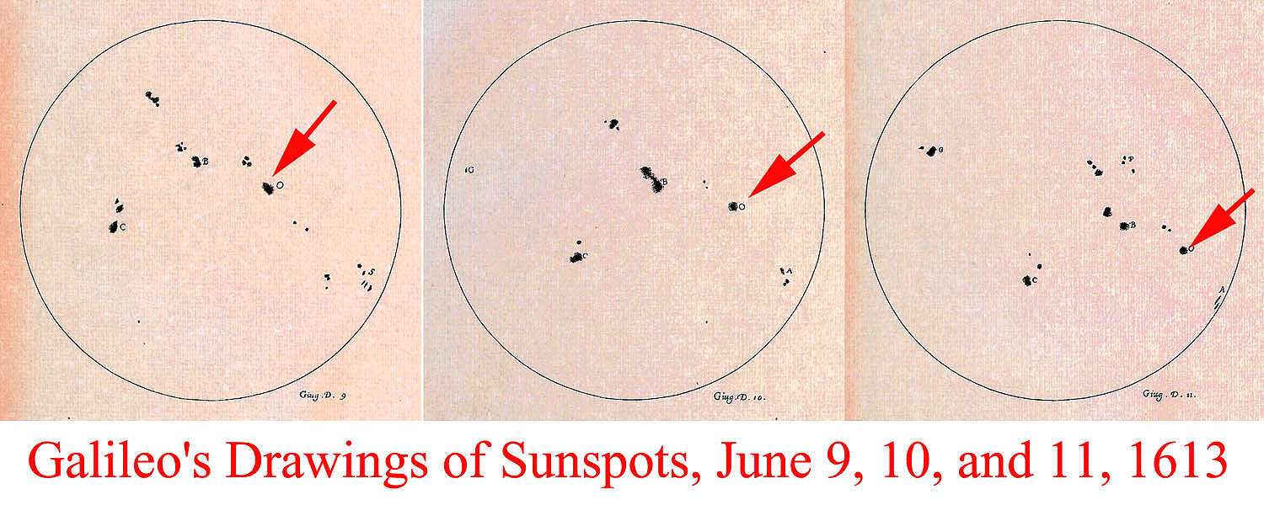
The motion of the spots affords us a way of measuring the rotation rate of the solar surface. Solar rotation is one of the principal factors affecting the roughly 11-year cycle of sunspot activity, solar flares, and other phenomena. In the 1860’s Richard Christopher Carrington used sunspots to determine that the period of rotation of the Sun depends on latitude. Spots near the equator of the Sun go around every 25 days, while spots near latitude 45 go around once every 28 days. This so called differential rotation would not be possible if the Sun were a solid body.

Determining the solar rotation rate from sunspots is easy in principle---you time how fast a spot takes to go once around the Sun, or perhaps some fraction of the distance around the Sun. However it is difficult to watch the Sun continuously. The Sun is below the horizon about half of the day (except near the poles), and weather often interferes with observations. So in practice, it is rather difficult to get a continuous record of where the spots are day by day.
In 1995, however, astronomers at the National Solar Observatory completed the construction of a global network of telescopes capable of continuous observations of the Sun. When the Sun sets on one telescope, the Sun is still high in the sky at another telescope. The six telescopes in the network are located in Big Bear, California; Mauna Loa, Hawaii; Learmonth, Australia; Udiapur, India; El Teide, Tenerife (The Canary Islands, in the Atlantic Ocean), and Cerro Tololo, Chile. The telescopes are operated by the Global Oscillation Network Group (GONG) based in Tucson, Arizona. Because the Sun is so bright, the telescopes are small, and can be housed in modular trailers, not in the large domes used for telescopes that look at the stars (Figure 2.). The GONG telescopes provided the images used in this exercise---check out the GONG website at http://gong.nso.edu for details about the GONG Project and the telescope sites.
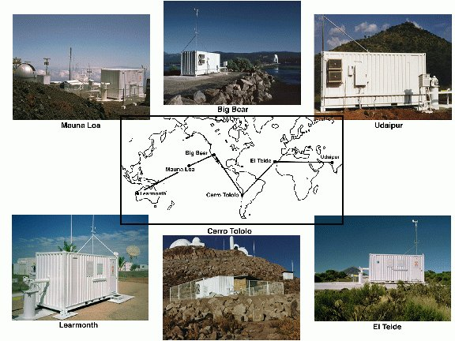

Figure 2: The GONG network
The GONG telescopes are robotic telescopes, imaging the Sun once per minute from sunrise to sunset without human interaction. The telescopes are designed to monitor “solar oscillations.” Sound waves (acoustic waves) are generated deep inside the Sun. Some of these waves travelling through the Sun can become "trapped" returning to the surface over and over again (see Figure 3). The properties of these waves depend on the internal structure of the Sun, so astronomers can infer the internal structure of the Sun from observations of the waves that appear at the surface. The problem is complicated,
though, in that numerous waves are present on the surface all the time. The surface of the Sun is similar to the surface of the ocean, having peaks and valleys created by the mixing of many waves of different wavelengths (see Figure 4). Accurate determinations of the structure of the interior of the Sun therefore require numerous, short exposure images to be taken in succession for long periods of time (from a minimum of about four hours to months on end). For the purposes of our exercise on solar rotation, however, the important thing is that the GONG images can also be used to track sunspots.
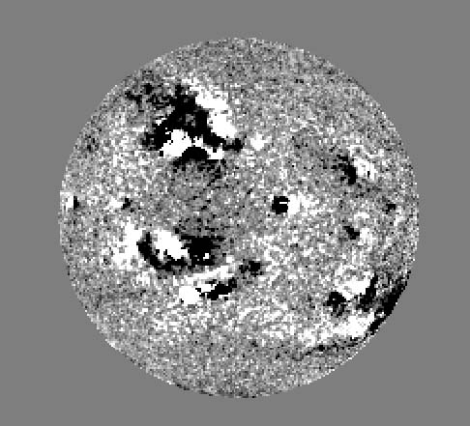
Figure 3: Sound waves bouncing around inside the Sun.
Figure 4: A velocity image from one of the GONG solar telescopes - dark regions correspond to troughs, bright regions to peaks.
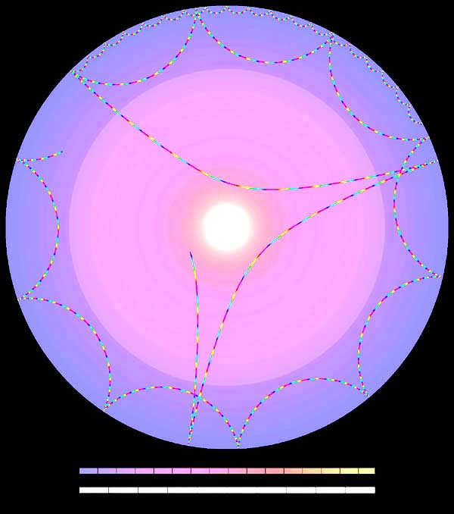

The database for the CLEA Solar Rotation Lab consists of 368 images obtained at the GONG solar telescopes between January 1, 2002 and April 30, 2002. Although images are acquired once per minute while the Sun is up at each of the GONG solar telescopes (averaging a total of about 3600 images per day!), the database for this lab contains only three images per day. On average that’s one image every 8 hours, which is more than sufficient to determine the rate of rotation of the Sun.

A note about the images: The original images from the GONG telescopes have been processed to remove artifacts from the CCD cameras, to make the images uniform in brightness, and to orient all of the images in the same direction. Other than that, the images in this exercise retain the high fidelity of the originals (Figure 5). These are the best images to date from which the rotation rate of the Sun can be determined, not just because they were taken so frequently, but also because they have very high spatial resolution (that is, they show a lot of fine detail) . The images are 860 x 860 pixels in size, and oriented so that north is up, westward on the sun is to the left, and eastward on the sun is to the right. The solar disk is about 720 pixels across on each image. Each pixel corresponds to 2.5 arcseconds, or about 1800 km on the surface of the Sun at the center of the disk. Because of the geometry of projecting a sphere (the Sun) onto a plane (the CCD camera), each pixel corresponds to larger and larger areas the closer it is to the edge of the solar disk. At a distance 95% out to the edge of the Sun, for example, each pixel corresponds to 6000 km on the surface.
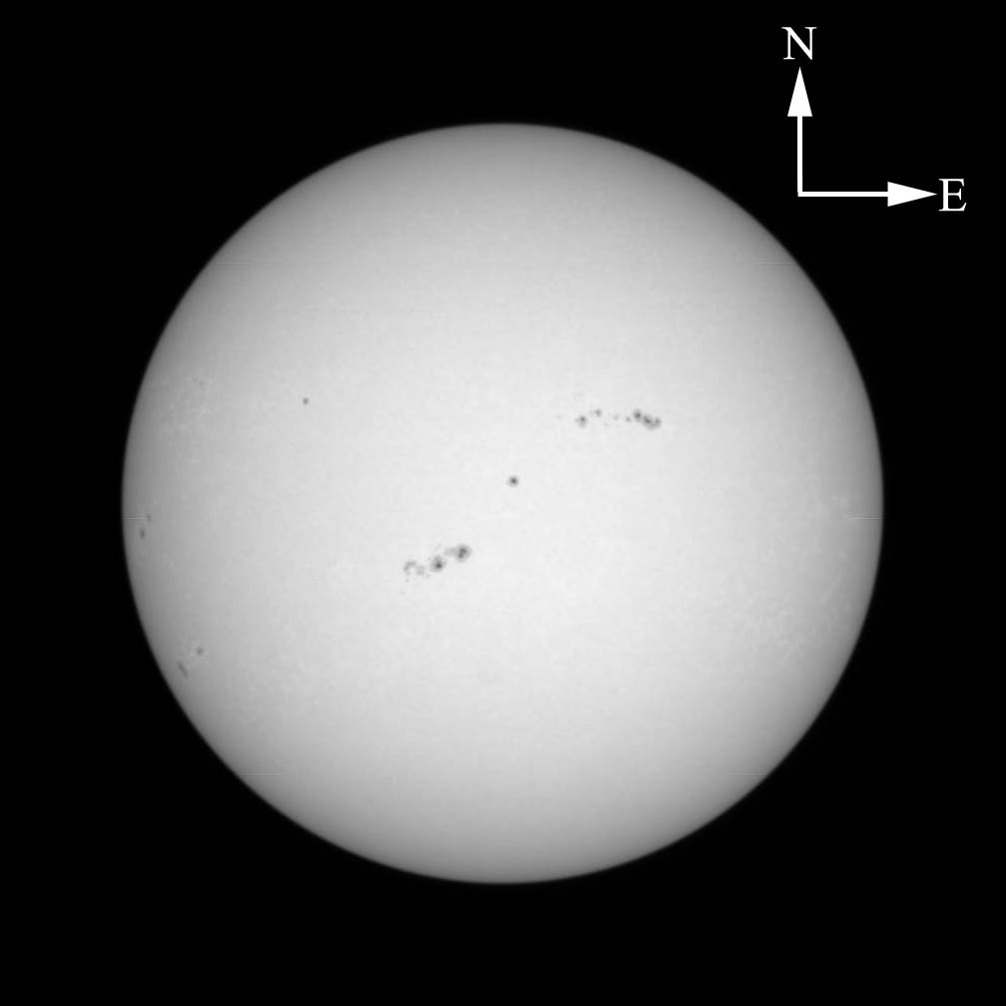

Figure 5: A typical image of the Sun from GONG .
Arrows have been added to indicate
directions on the solar globe.
Overall Strategy: Things to think about when analyzing the pictures.

The CLEA software associated with this exercise allows you to display images of the Sun from the GONG solar telescopes and to measure the positions of sunspots. The software details will be described later, but the basic idea of the scientific problem you will be investigating can be understood even before you get into the details of the software.

Your primary goal is to use a series of the GONG images to figure out as precisely as possible how long it takes the Sun to rotate once, a number we call the sidereal rotation period of the Sun. Your value should be expressed as a number and a fraction of a day (e.g. 22.11 days). Since the images you have are spaced about 8 hours apart, you might think you could at least determine the rotation rate to the nearest 8 hours, or 0.33 day.

The easiest way to determine the period of rotation of the Sun would be to find a sunspot and just watch it until it comes back to the same place on the images. But here are some questions you should ask yourself, and which you should try to answer when looking at the images:
- Can you find a sunspot or group of sunspots on the Sun, and then recognize it when it comes around again? It will be clear, as you do this, which way the Sun is rotating.

- Do sunspots live long enough on the surface of the Sun to survive one rotation?
- Is it possible that there might be a missing picture (due to inclement weather or a broken telescope) at the time the spot came around again?
- What if the rotation rate of the Sun isn’t evenly divisible by 8 hours (the average time between the GONG images in the database)? Will the spot return to exactly the same place on the images after one rotation of the Sun?
- Can you think of several strategies that don’t require you to see a sunspot make one complete rotation which you can use to determine how long it takes the Sun to rotate through a full 360 degrees? (Hint: What if you were only able to measure how long it takes to rotate through 30 degrees?)

Calculating the Sidereal Period of Rotation of the Sun From your Measurements

The value you determine from Earth-based images of the Sun is what is called the synodic period of rotation. This is the apparent rotation period of the Sun as seen from the Earth, not the “true” rotation period of the Sun because the Earth is in motion, orbiting around the Sun from west to east as the Sun rotates. The “true” rotation period of the Sun, known as the sidereal period of rotation, is the time it takes for a point on the Sun to rotate once with respect to the distant stars. In the time that it takes a point on the Sun to turn 360 degrees with respect to the stars, the Earth will have moved ahead in its orbit. The Sun will have to rotate a little further to catch up to the Earth. Therefore the synodic period is a bit longer than the sidereal period.

Fortunately, we can correct for this added time, since we know how fast the earth goes around the Sun (about one revolution every 365.25 days). If P is the sidereal period of rotation in days (this is what you want to determine), and S is the synodic period of rotation of the Sun in days (this is what you have measured), then

P= (S × 365.25) / (S + 365.25)

Equipment

This experiment requires a Windows-based computer, the CLEA program The Period of Rotation of Rotation of the Sun, and a scientific calculator. (Note that modern computers usually provide such a calculator.) You may also find it useful, but not essential, to use a spreadsheet and/or graph paper.

A User’s guide to The Period of Rotation of the Sun
A Program for Displaying and Measuring Sunspots on Solar Images

Starting the Program

Your computer should be turned on and running Windows. Your instructor will tell you how to find the icon or menu bar for starting the Period of Rotation of the Sun exercise. Position the mouse over the icon or menu bar and click to start the program. When the program starts, the CLEA logo should appear in a window on your screen. Go to the File menu at the top of that window, click on it, and select the Login option from the menu. Fill in the form that appears with your name (and partner’s name, if applicable). Do not use punctuation marks. Press “Tab” to move to the next text block, or click in each text block to enter the next name. Next enter the Laboratory table number or letter if it is not already filled in for you. Click in appropriate field to correct any errors. When all the information has been entered to your satisfaction, click OK to continue, and click “yes” when asked if you are finished logging in. The opening screen of the Period of Rotation of the Sun lab will then appear.

Accessing the HELP Files

You may, at any time, select Help from the menu to receive on-line help. Click Help located on the right hand side of the menu bar. Within Help…Topics, there are five options that you can select: Login, Files, Images, Reports, and Close the Program. LogIn informs you of the initial steps required to begin the program. Files provides information on the types of files used in this exercise. Images explains how to retrieve images, make measurements on images, and print images. Help…Topic…Reports shows you how you can review your recorded data. Close the Program gives the procedure on how to exit the program as well as a reminder of any unsaved data. About This Exercise displays the title and version number of the program as well as the copyright information.

Loading and Displaying Images

When you first run the program you will see a Main File List area with two frames, the left labeled loaded images and the right labeled image database. Both will be blank. After you load the image database from the File menu, you will see a list of the available GONG images, ordered by date, in the image database window. You can load and display an image in one of two ways. You can right-click on the date of the image you want to display, then select load image from the popup box that appears (which also lets you print the list of images or search for a particular date). Or you can simply double-click the left mouse button on the date of the image you want to display.
When you first load an image, its date is also displayed in the list of loaded images. The last-selected image is automatically displayed in a large popup image display window.
You can display any of the images in the loaded images window by double clicking on the image date. Or you can use the right mouse button to bring up a pop-up menu that will allow you to display the image, remove it, or remove all the images currently loaded.

Figure 6: Main window and image display window.
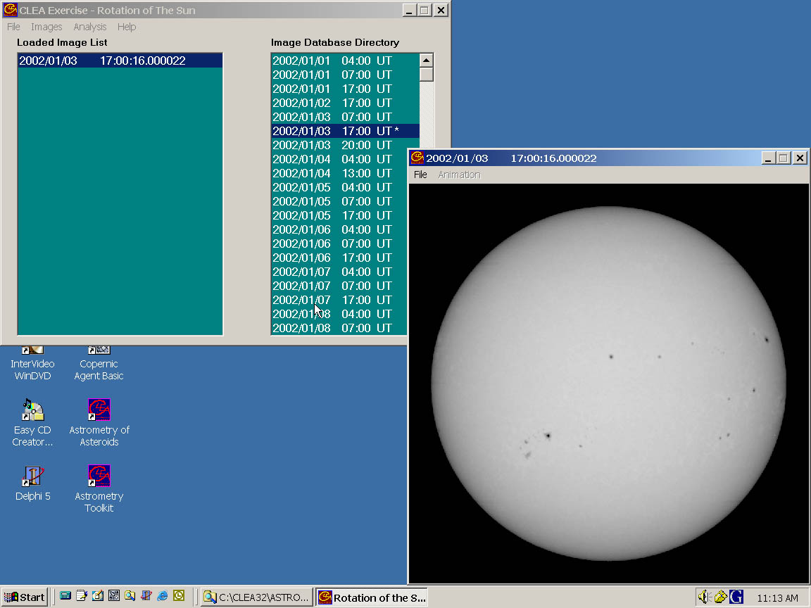

Animating a Series of images

Once you have several images loaded, you can have the program display each one in sequence automatically as an animation. You can do this in either of two ways. On the main menu bar over the list of images, select the images option, then select animate. Or on the menu bar over the image display window, select animation…start. You can stop the animation using the same menu bars.

Measuring the Positions of Spots

The image display permits you to measure the positions of points on the Sun. To start measuring sunspot positions, choose file..image..measure from the menu bar at the top of the image display. A small window will appear with digits to indicate the position of the cursor in pixels and in apparent heliographic coordinates. The position of the cursor is updated whenever you click the left mouse button, or continuously if you hold the button down. You will also see a small magnification window that shows the area around the cursor. (see figure 7). Pixels are of course just the little blocks that make up the picture, and pixel 0,0 is right in the center of the image. Apparent heliographic coordinates, however, require some explanation.
Heliographic coordinates are similar to longitude and latitude on Earth. The poles of the Sun are at +90˚ (north) latitude and -90˚ (south) latitude. The equator of the Sun is at 0˚ latitude. The 0˚ heliographic longitude line runs right down the middle of the solar disk as you see it, with positive lines of longitude to the right, and negative ones to the left (see figure 8). Unlike longitude lines on the Earth, heliographic longitude lines are not fixed to the surface of the Sun and do not rotate with the Sun! The computer uses the x and y pixel values, plus a little trigonometry, to calculate the apparent heliographic latitude and longitude for the location of the cursor on the image.

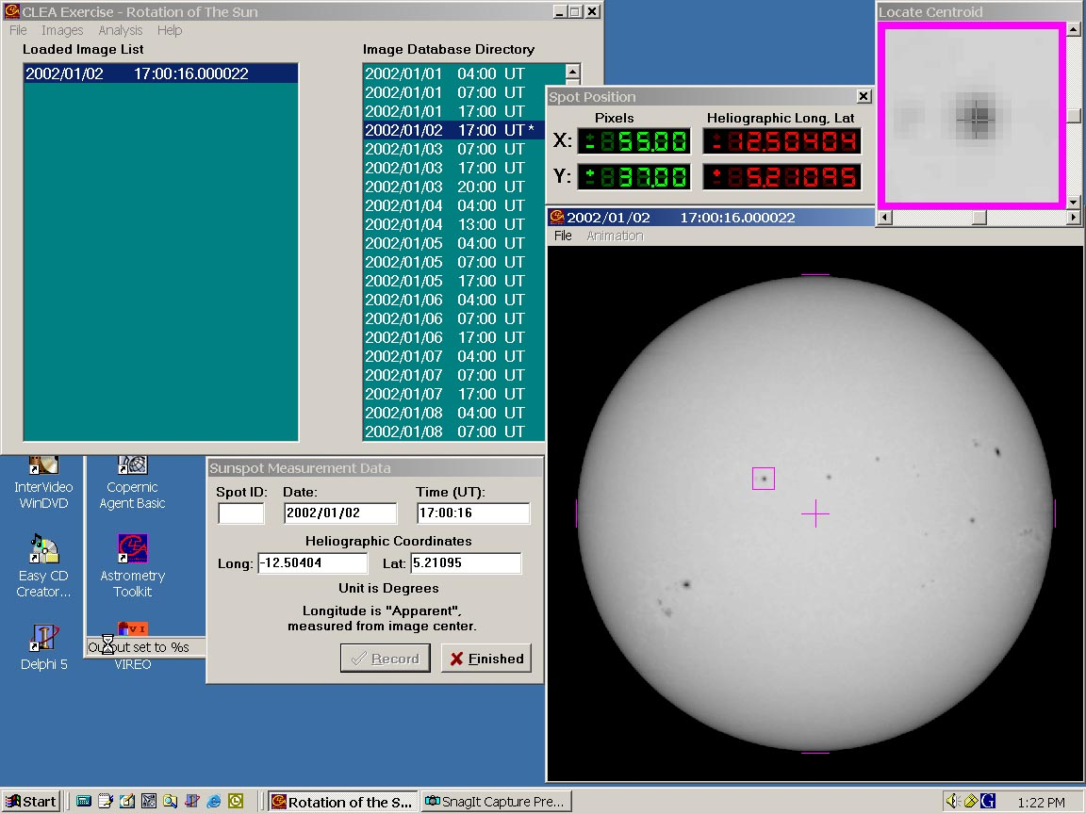

Figure 7: Measuring the positions of spots on solar images

There is one complication you might want to note. Even though the center of the solar disk in every image is at 0˚ longitude, it is not at 0˚ latitude. That is because the axis of rotation of the Sun is tilted by about 7˚ from the plane of the ecliptic (the plane of the orbit of the Earth). At some times during the year the Sun appears tipped away from us, and at other times it appears tipped toward us. Only in June and December do we see the axis at right angles to our line of sight. When measuring positions on the images, you will find that the edge of the Sun is not always ±90° heliographic longitude; this is also a result of the tilt of the solar globe.

Figure 8: Heliographic Coordinates
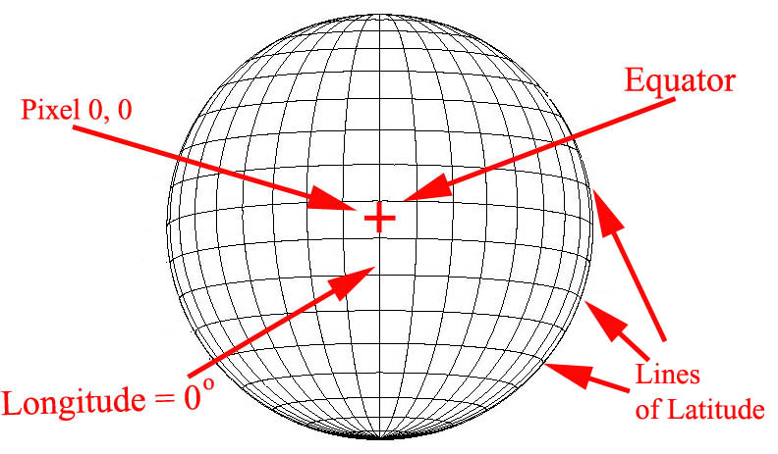

The apparent heliographic coordinate system is a good one for measuring the positions of sunspots. Consider the following questions to test your understanding of what to expect:
- Imagine a spot located to the left of the centerline of the Sun. Is its longitude a positive or negative number?

- Imagine a spot located to the right of the centerline of the Sun. Is its longitude a positive or negative number?

- If you had a series of consecutive pictures taken over the course of several days, how would you expect that the apparent latitude of a sunspot would change from one picture to the next?

- If you had a series of consecutive pictures taken over the course of several days, how would you expect that the apparent longitude of a sunspot would change from one picture to the next?

Recording Data

When you are measuring sunspot positions, there will be a small window on the screen labeled Sunspot Measurement Data. When you click the “record” button, the image date and time and the position of the cursor are written to a data file. If your instructor has turned on the “automatic centroiding” feature, the software will calculate the precise center of the sunspot beneath the cursor when you click the right mouse button. If the automatic centroiding feature is not available, place the cursor as close to the center of the spot as possible before recording the position. The small magnification window helps by giving a magnified view of where the cursor is pointing, and you can make fine adjustments using the sliders on the magnification window or the arrow buttons on the keyboard. ( When using the arrow buttons, note that you have to “activate” either the vertical or horizontal motion of the cursor by clicking on the vertical or horizontal slider on the magnification button---the arrow keys will either move the cursor horizontally or vertically, but not both at the same time. )

There’s also a space in the Sunspot Measurement Data window to write in a letter or number or name that identifies a particular sunspot. Of course if you’re going to be measuring the same spot on several images, be sure to use the same identification on each picture.

Seeing a Table of Recorded Data

At any time after you have some data recorded, you can view all the recorded data in a separate Sunspot Position Measurements window. To do this, go back to the Main File List window and choose file..measurement data from the main menu bar. There are choices that let you view the current data, or load a file of previously saved data. If you choose to view the list, you will see the data window appear on the screen. (see Figure 9). The columns are labeled; the data for each sunspot is sorted by the letter, number, or name of the sunspot in the order of increasing time. In addition to the date and time of the observation, the window will list the Julian Date of the observation, which is a running day number and fraction that is convenient for keeping track of astronomical times. Instead of having to remember the number of days in a particular month when subtracting one date from another, you simply subtract one Julian Date number from another to get the number of days between two observations. A Julian Date begins at Noon, Universal Time; 0.5 day, of course, is 12 hours; each 0.0001 day is about 8 seconds.

You can print the data in the Sunspot Position Measurements window by choosing List..print from the menu bar. You can edit individual entries (if you made a mistake in entering data) by right-clicking the mouse on the line you want to edit. You can delete a line by selecting it and then choosing Edit..Delete selected measurement from the menu bar.

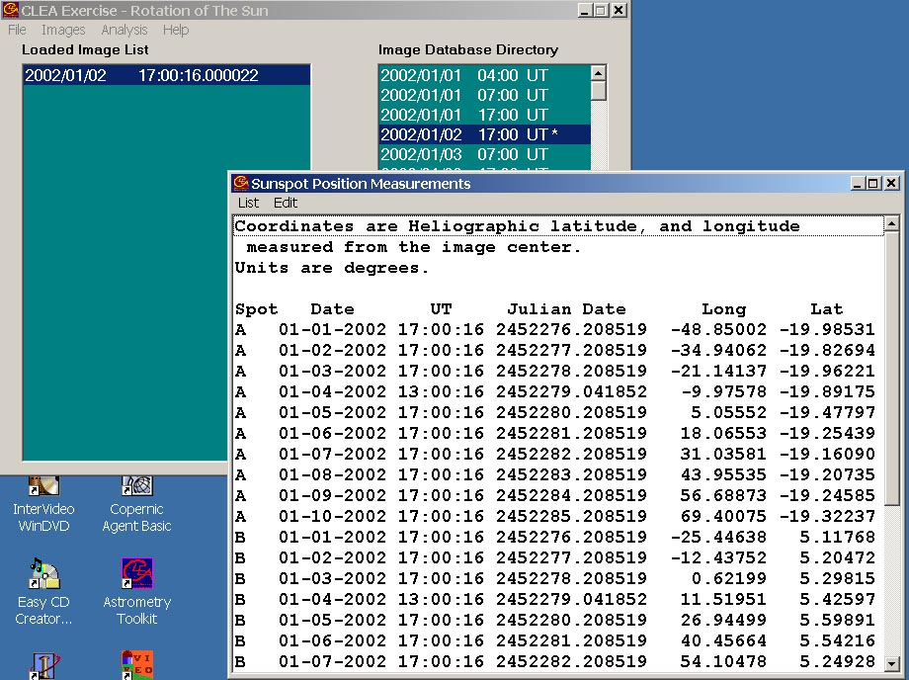
Figure 9 : Recorded data listings.
Plotting Latitudes and Longitudes of Spots versus Time

Recorded latitude and longitude for a given spot can be plotted versus time using the plot data menu choice from the main file list window. You can choose to plot either the latitude or the longitude for each spot. The plots can be printed. The program can also calculate best fit straight lines through the data, and display the slope and the intercept of the line for each set of data belonging to each sunspot you have measured. The slope of the line---expressed in degrees per day (the rate of motion of the sunspot you’re measuring)---is displayed at the lower right of the plot, as is the intercept (the time in Julian days at which the spot crosses the center of the image). You can make adjustments to these lines to get the best fit in your own judgment. (see Figure 10.)

The data for several different sunspots can be plotted on the same graph, or you can open separate windows for each set of data and plot the data for just one spot at a time. When displaying multiple plots, clicking on a particular plot will select that plot for line fitting or editing.

Plotting data like this can be a very useful way to determine the rotation period of the Sun, but you may prefer to use a spreadsheet or devise your own method that makes use of the data you copy off the screen. In your lab report or lab notebook, be sure to describe just how you are using the program, so that your instructor can see how you got your answers.

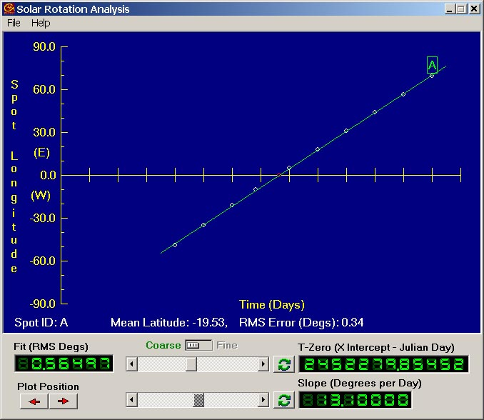
Figure 10: Plotting data and fitting a line.
Figure 11: Multiple plots on the same graph.
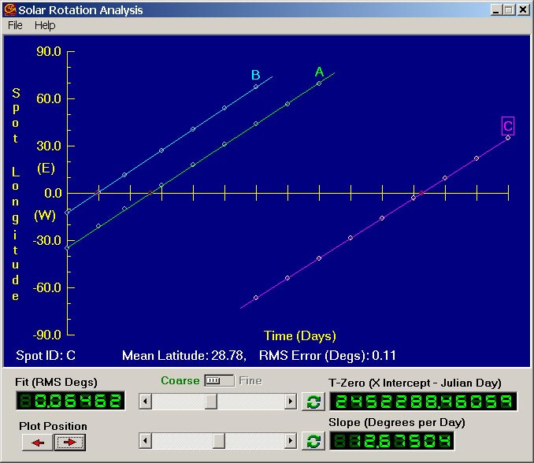

Using the program in the Period of Rotation Exercise

There are numerous ways in which you can use this program to determine the solar rotation rate. Your instructor may provide you with a detailed procedure for this exercise, or may simply ask you to experiment with the program to discover your own method for determining the rotation rate. The user’s guide on the previous pages is only a guide, not a prescription. Experiment with the program. Try discovering some of its possibilities by trial and error, and by reading the help screens for the program. Ask your instructor as questions arise.
The Period of Rotation of the Sun: Discovery-Based Procedure

The Problem:
To determine an accurate value for the sidereal rotation period of the Sun.

Resources:
- Images from the GONG telescopes.
- CLEA Software for displaying and measuring sunspots on the GONG images.
- Other software, calculators, and reference works you choose to use.
- Your instructors and lab partners who are available for discussion and help.

Report Format options

1) Raw data and brief analysis:
Submit the following data stapled together:
- Print outs of sample data
  - Table of measurements
  - Plots used to derive results.
- A sheet containing formulas used and sample calculations used in the experiment.
- A paragraph or two stating the final result.

2) Journal Article format:

The report should describe what you did, what you recorded, how you analyzed the data, and what you concluded. Be brief---you don’t need to write down every mouse click you made. But be clear, so that if someone unfamiliar with the experiment were to read it, that person could understand just what you did and why. Include the following sections:
- Introduction describing the background and motivation for the work.
- Data and basic measurements, including, if applicable
  - A sample image.
  - Printout of data tables
  - A brief description of what measurements you made and how you made them.
- Plots and analysis
  - Any graphs you used.
  - Description of the method used to turn the raw data (e.g. sunspot positions) into desired results; Describe the logic of the method and show the formulas used in any calculations.
  - Tables of calculated data if more than one number was calculated, or if several numbers were averaged together.
- Summary and conclusions: State what you did and what the important results were.

Extra Credit Project: Latitude Dependence of the Solar Rotation Rate

Once you feel understand how to determine the rate of rotation of the Sun using sunspots, it’s possible to demonstrate that the surface of the Sun doesn’t rotate like a solid body, but has differential rotation. You will need to select sunspots at different latitudes for this investigation. It will be best to search through the images to find three or four whose latitudes are as different as possible---one close to the equator, and the others further and further from the equator, with one being as far from the equator as possible. You may also find that most of the spots on the 2002 images are very close to the equator---near sunspot maximum the spots tend to appear near the equator. You may want to see if your instructor has additional GONG images taken at a different time in the solar cycle.

The Period of Rotation of the Sun: Step-by-Step Procedure

1) Run the CLEA Period of Rotation of the Sun software. Log in. Choose File…run and the main data window will appear. Choose File..image database..image directory..load and the times of available images of the Sun will appear in the image database window (the right half of the window.) Scroll down the window to see what dates are available.
All the images were taken between these dates: ________________________________ and ___________________________.

2) Select 6 or 7 images by double-clicking the left mouse button. The dates of the images will appear in the loaded images window (the left half of the main window). An image display window will also open, showing you one of the loaded images of the Sun. Animate the images by choosing Animation..start on this image display window. You can stop the animation by choosing Animation…stop from the menu.

Watch the sunspots. In which direction does the Sun rotate on these images (L to R or R to L)? _____________________________________.
Which side of the images is North? _______________.
Which side is Eastward on the sun?____________________.

3) Choose a sunspot to measure, call it sunspot A. Choose a sunspot that has just rotated into view, then load all of the images for 4 or 5 days following the image in which the sunspot first appears (see step #2 for loading images). Anything listed in the loaded images window can be displayed by double-clicking on the listing. If the listing gets cluttered with images you don’t intend to measure (because they contain no suitable spots), you can clean it up by choosing Images…cut or Images….clear all images on the menu bar.

4) Next
- If your instructor is having you make a written record of your data, list the dates of the images you have chosen in the data table for sunspot rotation (several copies of this may be provided by your instructor), and make a sketch of the position of the spot you are measuring in the space provided. (Just one typical image will do).

- If your instructor is having you use the computer to print out records of your data, you can proceed to the next step.

5) Measure and record the heliographic coordinates of sunspot A on each of your chosen images using the cursor and the mouse. Follow the instructions in the software guide provided with this exercise (see page 9). If your instructor is having you make a written record of your data, record the data on the data table provided. Otherwise, the computer will record the data in a file that you can print later.

6) Plot and analyze the coordinate data for sunspot A. Choose Analysis..plot fit data from the main window menu. The Solar Rotation Analysis window will appear. Choose File..dataset..load ..longitude values from the Solar Rotation Analysis menu bar and select the values for spot A. The data will be plotted (time on the x axis and heliographic longitude on the y axis.) Depending on how your instructor has set up the software, the program will either compute a best fit line through the data or allow you to fit the line yourself using two sliders. If you are fitting the line with the sliders, try to get the lowest “error of fit” as displayed in the digital readout labled “fit (RMS Degrees)” in the lower left of the Analysis window.

When you are satisfied with your data, write your results for the slope and the intercept of the graph in ANALYSIS TABLE 1 below. Also, record the slope and intercept you have measured in a data file by choosing File..record results from the Analysis window menu bar. Print the graph showing the line and your fit by choosing File..print on the Analysis window menu bar and submit it with this report.

Analysis table 1: Rate of motion of selected sunspots
SPOT IDENTIFIER | Slope (Degrees per Day) | Intercept (Julian Day)
A
B
C

7) Measure the rotation rate of two other spots, following the steps above, and write the results in Analysis Table 1 above.

8) You can now calculate the synodic rotation rate and the sidereal rotation rate of the Sun.
- The slope of the sunspot longitude versus time line is the number of degrees per day a sunspot moves on average. If you divide this number into 360, you get the number of days it takes for the spot to rotate through 360 degrees---which is the synodic rotation rate of the Sun. If we let S equal the synodic rotation rate of the Sun,

S[days] = 360 [degrees] / Slope[degrees per day]
- Once you have the synodic period, use the formula on page 8 to calculate the sidereal rotation period of the Sun. Average your results for the three spots, and record the average value on the table, too. Fill in Analysis Table 2.
Analysis Table 2: Sidereal and Synodic Rotation Rate Calculations
SPOT IDENTIFIER | Synodic Rotation Rate (days) | Sidereal Rotation Rate (days)
A
B
C
AVERAGE SIDEREAL ROTATION RATE (days)
9) Try opening the analysis window and plotting latitude data for one of the spots. What can you say about how the latitude of a sunspot changes with time?

10) If you are using the computer to record and print your results, print out the coordinate measurements for each spot by choosing File..measurement data..view/edit. A Sunspot position measurement window will appear. Choose List..print from the menu bar to print your data. Attach it to the printed report when you turn it in.

QUESTIONS TO CONSIDER:

1) Why would you expect there to be more uncertainty in the heliographic coordinates of sunspots near the edge of the sun?

2) By examining a representative sample of images, estimate the average number of sunspots visible on any day between January and April, 2002.

Now
SPOT IDENTIFICATION (Number or Letter) ===
Date and time |  | Heliocentric Longitude | Heliocentric Latitude

DATA TABLE FOR SUNSPOT ROTATION

WARNING: Do not look directly at the Sun through a telescope! The intense Sunlight will cause permanent eye damage. The Sun can be viewed through a telescope only if a solar filter is used in conjunction with the telescope. Solar filters reject more than 96% of the light of the Sun. These filters are specially designed to fit specific telescopes, and should be attached firmly to the telescope so that they don’t fall off during viewing. The Sun can also be viewed with a telescope using a technique called “eyepiece projection”. In this technique, the image of the Sun is projected onto a white screen for viewing.

